**PES UNIVERSITY**

**Department of Computer Science & Engineering**



**DBMS - UE20CS301**

**Mini Project**

**Title of the****Project-**

**Salon**

**Management****System**

**Submitted to: Vidyashree mam**

**Submitted by:**

NAME- Praneeth Reddy

SRN- PES2UG20CS276

SECTION- E

# TABLE OF CONTENTS

|  |  |  |  |  |
| --- | --- | --- | --- | --- |
|  | **Sl.No** | **Title** |  | **Page No** |
| 1 |  | **Short Description and Scope of the project** | 4 |  |
| 2 |  | **ER Diagram** | 5 |  |
| 3 |  | **relational schema** | 6 |  |
| 4 |  | **DDL statements -**  **Building the database** | 7 |  |
| 5 |  | **Populating the Database** | 16 |  |
| 6 |  | **Join Queries** | 20 |  |
| 7 |  | **Aggregate Functions** | 21 |  |
| 8 |  | **Set Operations** | 24 |  |
| 9 |  | **Functions and Procedures** | 26 |  |
| 10 |  | **Triggers and Cursors** | 28 |  |
| 11 |  | **Developing a Frontend** | 30 |  |
| 12 |  | **Conclusions** | 48 |  |
| 13 |  | **References** | 49 |  |

# Short Description and Scope of the Project

**Proposed project description**

Salon Management System is focused on improving the salon's system services. It is a standalone system that can be accessed by the admin which is the owner and the employees of the salon

* This is an online system which helps customers to submit their appointments (date andtime), • It helps to overcome problems of time wastage for customers waiting to be worked on.
* Other valuable features like customer and service management, invoices and report generationare also included in the system.

**Plan of work and product description**:

Planning basic design and architecture. Fine-tuning the requirements according to the design.

Implementation stack:

Frontend: HTML, CSS and JavaScript.

Backend: PHP.

Database: MySQL database

**Features**

* User Registration
* User login system
* Change password
* Forgot password
* Profile management system.
* Service and customer management
* Registering and managing system users(Admins)• Appointments management, Invoices and many more **Non - functional Requirements:**
* Maintainability
* Serviceability
* Security
* Usability

# ER Diagram

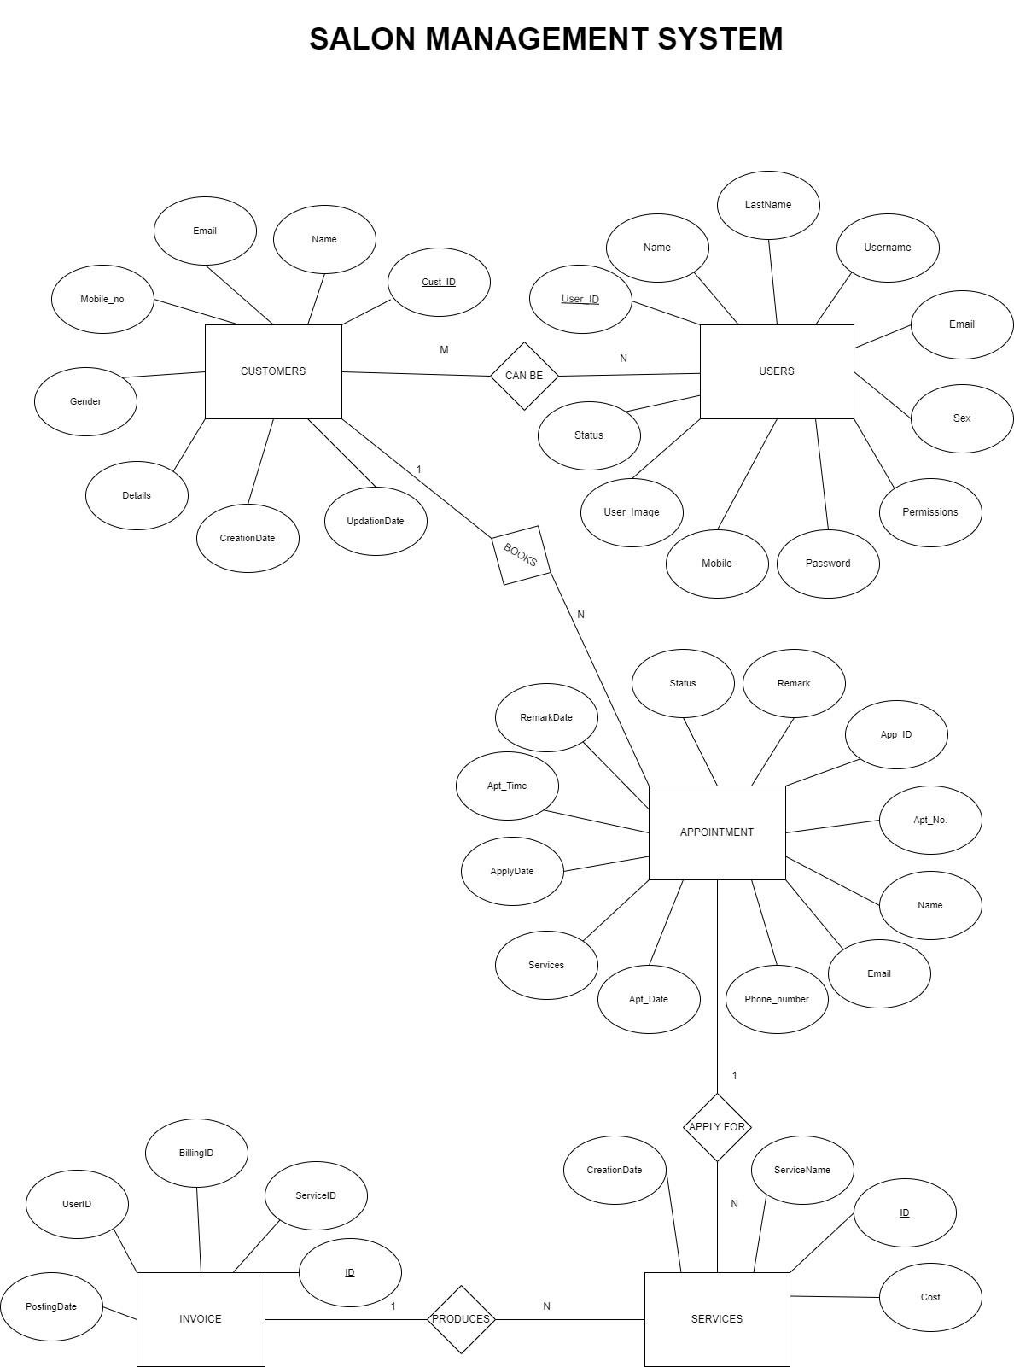

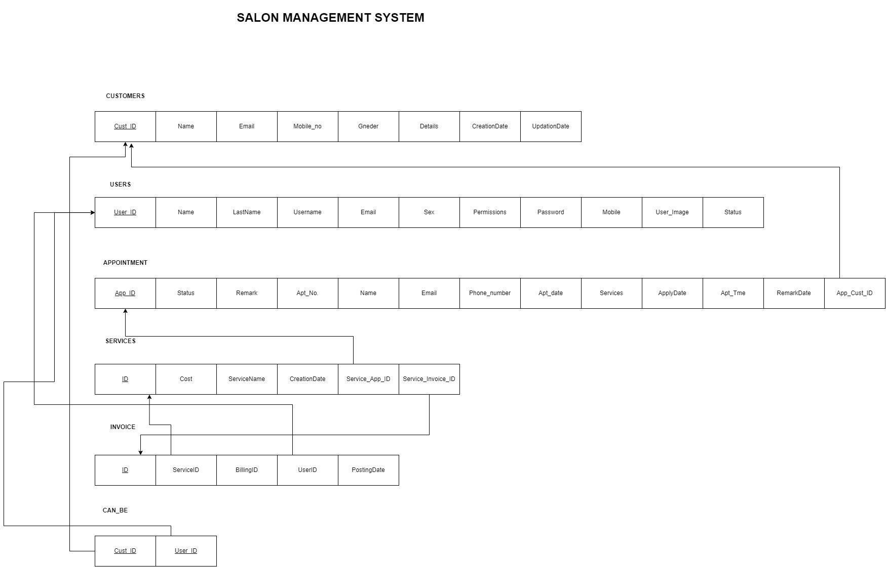 **Relational Schema**

**DDL statements - Building the database**

SET SQL_MODE = "NO_AUTO_VALUE_ON_ZERO";

START TRANSACTION;

SET time_zone = "+00:00";

-- Database: `bpmsdb`

-- Table structure for table `tbladmin`

CREATE TABLE `tbladmin` (

`ID` int(10) NOT NULL,

`AdminName` char(50) DEFAULT NULL,

`UserName` char(50) DEFAULT NULL,

`MobileNumber` bigint(10) DEFAULT NULL,

`Email` varchar(200) DEFAULT NULL,

`Password` varchar(200) DEFAULT NULL,

`AdminRegdate` timestamp NULL DEFAULT current_timestamp()

) ENGINE=InnoDB DEFAULT CHARSET=latin1;

--

-- Dumping data for table `tbladmin`

--

INSERT INTO `tbladmin` (`ID`, `AdminName`, `UserName`, `MobileNumber`, `Email`, `Password`, `AdminRegdate`) VALUES

(1, 'Admin', 'admin', 7898799798, 'tester1@gmail.com', 'f925916e2754e5e03f75dd58a5733251', '2022-05-25 06:21:50');

-- Table structure for table `tblbook`

--

CREATE TABLE `tblbook` (

`ID` int(10) NOT NULL,

`UserID` int(10) DEFAULT NULL,

`AptNumber` int(10) DEFAULT NULL,

`AptDate` date DEFAULT NULL,

`AptTime` time DEFAULT NULL,

`Message` mediumtext DEFAULT NULL,

`BookingDate` timestamp NULL DEFAULT current_timestamp(),

`Remark` varchar(250) DEFAULT NULL,

`Status` varchar(250) DEFAULT NULL,

`RemarkDate` timestamp NULL DEFAULT NULL ON UPDATE current_timestamp()

) ENGINE=InnoDB DEFAULT CHARSET=latin1;

--

-- Dumping data for table `tblbook`

--

INSERT INTO `tblbook` (`ID`, `UserID`, `AptNumber`, `AptDate`, `AptTime`, `Message`,

`BookingDate`, `Remark`, `Status`, `RemarkDate`) VALUES

(1, 7, 729411824, '2022-05-12', '19:03:00', 'Test msg', '2022-05-12 18:30:00', 'Your appointment has been book.', 'Selected', '2022-05-13 06:11:41'),

(2, 7, 767068476, '2022-05-14', '09:00:00', 'fghfshdgfahgrfgh', '2022-05-12 18:30:00', 'Sorry your appointment has been cancelled', 'Rejected', '2022-05-13 06:14:39'),

(4, 10, 931783426, '2022-05-18', '15:40:00', 'NA', '2022-05-15 05:04:13', NULL, NULL, NULL),

(5, 10, 284544154, '2022-05-18', '15:40:00', 'NA', '2022-05-15 05:04:13', NULL, NULL, NULL),

(6, 10, 494039785, '2022-05-31', '14:47:00', 'NA', '2022-05-15 05:13:24', NULL, NULL, NULL), (8, 10, 891247645, '2022-05-28', '20:14:00', 'nA', '2022-05-28 08:43:55', 'Your booking is confirmed.', 'Selected', '2022-05-28 08:51:22'),

(9, 11, 985654240, '2022-05-29', '13:10:00', 'NA', '2022-05-29 07:34:47', 'Your appointment is confirmed', 'Selected', '2022-05-29 07:35:36');

-- Table structure for table `tblcontact`

--

CREATE TABLE `tblcontact` (

`ID` int(10) NOT NULL,

`FirstName` varchar(200) DEFAULT NULL,

`LastName` varchar(200) DEFAULT NULL,

`Phone` bigint(10) DEFAULT NULL,

`Email` varchar(200) DEFAULT NULL,

`Message` mediumtext DEFAULT NULL,

`EnquiryDate` timestamp NOT NULL DEFAULT current_timestamp(),

`IsRead` int(5) DEFAULT NULL

) ENGINE=InnoDB DEFAULT CHARSET=utf8mb4;

--

-- Dumping data for table `tblcontact`

--

INSERT INTO `tblcontact` (`ID`, `FirstName`, `LastName`, `Phone`, `Email`, `Message`, `EnquiryDate`, `IsRead`) VALUES

(5, 'Kajal', 'Sharma', 9879878798, 'kajal@gmail.com', 'guhgjhg', '2022-05-10 08:43:18', 1),

(6, 'Anuj', 'Kumar', 1234567890, 'ak@gmail.com', 'Need booking for marriage', '2022-06-01 01:05:47', 1);

--

-- Table structure for table `tblinvoice`

CREATE TABLE `tblinvoice` (

`id` int(11) NOT NULL,

`Userid` int(11) DEFAULT NULL,

`ServiceId` int(11) DEFAULT NULL,

`BillingId` int(11) DEFAULT NULL,

`PostingDate` timestamp NULL DEFAULT current_timestamp()

) ENGINE=InnoDB DEFAULT CHARSET=latin1;

-- Dumping data for table `tblinvoice`

--

INSERT INTO `tblinvoice` (`id`, `Userid`, `ServiceId`, `BillingId`, `PostingDate`) VALUES (4, 7, 4, 138889283, '2022-05-13 11:42:21'),

(5, 7, 9, 138889283, '2022-05-13 11:42:21'),

(6, 7, 16, 138889283, '2022-05-13 11:42:21'),

(7, 8, 3, 555850701, '2022-05-13 11:42:51'),

(8, 8, 6, 555850701, '2022-05-13 11:42:51'),

(9, 8, 9, 555850701, '2022-05-13 11:42:51'),

(10, 8, 11, 555850701, '2022-05-13 11:42:51'),

(13, 10, 1, 330026346, '2022-05-28 08:51:42'),

(14, 10, 2, 330026346, '2022-05-28 08:51:42'),

(15, 11, 2, 379060040, '2022-05-29 07:36:17'),

(16, 11, 5, 379060040, '2022-05-29 07:36:18'),

(17, 11, 6, 379060040, '2022-05-29 07:36:18'),

(18, 11, 12, 379060040, '2022-05-29 07:36:18'),

(19, 11, 3, 460087279, '2022-06-01 01:03:58');

-- -------------------------------------------------------- Table structure for table `tblpage`

--

CREATE TABLE `tblpage` (

`ID` int(10) NOT NULL,

`PageType` varchar(200) DEFAULT NULL,

`PageTitle` mediumtext DEFAULT NULL,

`PageDescription` mediumtext DEFAULT NULL,

`Email` varchar(200) DEFAULT NULL,

`MobileNumber` bigint(10) DEFAULT NULL,

`UpdationDate` date DEFAULT NULL,

`Timing` varchar(200) NOT NULL

) ENGINE=InnoDB DEFAULT CHARSET=latin1;

-- Dumping data for table `tblpage`

--

INSERT INTO `tblpage` (`ID`, `PageType`, `PageTitle`, `PageDescription`, `Email`, `MobileNumber`,

`UpdationDate`, `Timing`) VALUES

(1, 'aboutus', 'About Us', ' Our main focus is on quality and hygiene. Our Parlour is well equipped with advanced technology equipments and provides best quality services. Our staff is well trained and experienced, offering advanced services in Skin, Hair and Body Shaping that will provide you with a luxurious experience that leave you feeling relaxed and stress free. The specialities in the parlour are, apart from regular bleachings and Facials, many types of hairstyles, Bridal and cine make-up and different types of Facials &amp; fashion hair colourings.', NULL, NULL, NULL, ''),

(2, 'contactus', 'Contact Us', '890,Sector 62, Gyan Sarovar, GAIL Noida(Delhi/NCR)',

'info@gmail.com', 7896541236, NULL, '10:30 am to 7:30 pm');

-- --------------------------------------------------------

-- Table structure for table `tblservices`

--

CREATE TABLE `tblservices` (

`ID` int(10) NOT NULL,

`ServiceName` varchar(200) DEFAULT NULL,

`ServiceDescription` mediumtext DEFAULT NULL,

`Cost` int(10) DEFAULT NULL,

`Image` varchar(200) DEFAULT NULL,

`CreationDate` timestamp NULL DEFAULT current_timestamp()

) ENGINE=InnoDB DEFAULT CHARSET=latin1;

--

-- Dumping data for table `tblservices`

--

INSERT INTO `tblservices` (`ID`, `ServiceName`, `ServiceDescription`, `Cost`, `Image`, `CreationDate`) VALUES

(1, 'O3 Facial', 'O3 FacialO3 FacialO3 FacialO3 FacialO3 FacialO3 FacialO3 FacialO3 FacialO3

FacialO3 FacialO3 FacialO3 FacialO3 FacialO3 FacialO3 FacialO3 FacialO3 FacialO3 FacialO3

FacialO3 Facial', 1200, 'o3plus-professional-bridal-facial-kit-for-radiant-glowing-skin.jpg', '2022-05-24 22:37:38'),

(2, 'Fruit Facial', 'Fruit facials contain certain fruit acid like glycolic acid, alpha hydroxyl acid, citric acid, phenolic acid, vitamins and minerals in it. These acids are antiblemish, antiwrinkle and help your skin to exfoliate, it highly detoxifies your skin, it excretes out all the toxins and it hydrates your face', 500, 'How-To-Do-Fruit-Facial-At-Home.jpg', '2022-05-24 22:37:53'),

(3, 'Charcol Facial', 'Activated charcoal is created from bone char, coconut shells, peat, petroleum coke, coal, olive pits, bamboo, or sawdust. It is in the form of a fine black dust that is produced when regular charcoal is activated by exposing it to very high temperatures. This is done to alter its internal structure and increase its surface area to increase absorbability. The charcoal that you get after it has undergone this process is very porous.', 1000,

'b9fb9d37bdf15a699bc071ce49baea531652852364.jpg', '2022-05-24 22:37:10'),

(4, 'Deluxe Menicure', 'A luxurious treatment including a soak and moisturizing exfoliation, cuticle work, nails clipped and filed, hard skin is removed (pedicure) and a renewing mask is applied. A short massage and your nails are buffed and ready to paint.', 500,

'efc1a80c391be252d7d777a437f868701652852477.jpg', '2022-05-24 22:37:34'),

(5, 'Deluxe Pedicure', 'A luxurious treatment including a soak and moisturizing exfoliation, cuticle work, nails clipped and filed, hard skin is removed (pedicure) and a renewing mask is applied. A short massage and your nails are buffed and ready to paint.', 600,

'1e6ae4ada992769567b71815f124fac51652852492.jpg', '2022-05-24 22:37:47'),

(6, 'Normal Menicure', 'A luxurious treatment including a soak and moisturizing exfoliation, cuticle work, nails clipped and filed, hard skin is removed (pedicure) and a renewing mask is applied. A short massage and your nails are buffed and ready to paint.', 300,

'The-Dummys-Guide-To-Using-A-Manicure-Kit_OI.jpg', '2022-05-24 22:37:01'),

(7, 'Normal Pedicure', 'A luxurious treatment including a soak and moisturizing exfoliation, cuticle work, nails clipped and filed, hard skin is removed (pedicure) and a renewing mask is applied. A short massage and your nails are buffed and ready to paint.', 400,

'1e6ae4ada992769567b71815f124fac51652852492.jpg', '2022-05-24 22:37:19'),

(8, 'U-Shape Hair Cut', 'U-Shape Hair Cut', 250,

'cff8ad28cf40ebf4fbdd383fe546098d1652852593.jpg', '2022-05-24 22:37:38'),

(9, 'Layer Haircut', 'Layer Haircut', 550, '74375080377499ab76dad37484ee7f151652852649.jpg', '2022-05-24 22:37:53'),

(10, 'Rebonding', 'Hair rebonding is a chemical process that changes your hair\'s natural texture and creates a smooth, straight style. It\'s also called chemical straightening. Hair rebonding is typically performed by a licensed cosmetologist at your local hair salon.', 3999,

'c362f21370120580f5779a2d019392851652852555.jpg', '2022-05-24 22:37:08'),

(11, 'Loreal Hair Color(Full)', 'Loreal Hair Color(Full),Loreal Hair Color(Full),Loreal Hair Color(Full)', 1200, 'images.jpg', '2022-05-24 22:37:35'),

(12, 'Body Spa', 'It is typically a massage spa therapy that helps reduce pain. The technique involves using fingertips, palm, elbow, or even feet to apply firm pressure on certain body parts or acupoint to encourage blood flow and promote healing', 1500,

'efc1a80c391be252d7d777a437f868701652852477.jpg', '2022-05-19 01:38:27'),

(16, 'Aroma Oil Massage Therapy', 'Aroma Oil Massage TherapyAroma Oil Massage TherapyAroma

Oil Massage TherapyAroma Oil Massage TherapyAroma Oil Massage', 700,

'032b2cc936860b03048302d991c3498f1652173213.jpg', '2022-05-09 20:35:13');

--

-- Table structure for table `tbluser`

CREATE TABLE `tbluser` (

`ID` int(10) NOT NULL,

`FirstName` varchar(120) DEFAULT NULL,

`LastName` varchar(250) DEFAULT NULL,

`MobileNumber` bigint(10) DEFAULT NULL,

`Email` varchar(120) DEFAULT NULL,

`Password` varchar(120) DEFAULT NULL,

`RegDate` timestamp NULL DEFAULT current_timestamp()

) ENGINE=InnoDB DEFAULT CHARSET=latin1;

-- Dumping data for table `tbluser`

INSERT INTO `tbluser` (`ID`, `FirstName`, `LastName`, `MobileNumber`, `Email`, `Password`, `RegDate`) VALUES

(1, 'Khusi', NULL, 8956234569, 'khusi@gmail.com', '202cb962ac59075b964b07152d234b70', '202110-16 14:22:03'),

(2, 'Rishi Singh', NULL, 5689234578, 'rishi@gmail.com', '202cb962ac59075b964b07152d234b70', '2021-10-16 14:37:49'),

(3, 'Abir Singh', NULL, 2147483649, 'abir@gmail.com', '202cb962ac59075b964b07152d234b70', '2021-10-16 14:40:20'),

(4, 'Test Sample', NULL, 8797977779, 'sample@gmail.com',

'202cb962ac59075b964b07152d234b70', '2020-04-08 05:51:06'),

(5, 'Anuj kumar', NULL, 1236547890, 'test@test.com', 'f925916e2754e5e03f75dd58a5733251', '2020-05-07 08:52:34'),

(6, 'ghhg', NULL, 8888888888, 'c@gmail.com', '202cb962ac59075b964b07152d234b70', '2021-12-14 05:27:32'),

(7, 'Tina', 'Khan', 9789797987, 'tina@gmail.com', '202cb962ac59075b964b07152d234b70', '2022-0511 09:21:46'),

(8, 'Hima', 'Sharma', 8979798789, 'hima@gmail.com', '202cb962ac59075b964b07152d234b70', '2022-05-11 09:23:16'),

(10, 'Anuj', 'Kumar', 1425362514, 'ak@gmail.com', 'f925916e2754e5e03f75dd58a5733251', '2022-0515 05:03:32'),

(11, 'John', 'Doe', 1452632541, 'johndoe@gmail.com', 'f925916e2754e5e03f75dd58a5733251', '2022-05-29 07:33:58');

-- Table structure for table `can_be`

CREATE TABLE `can_be` (

`userID` int(10) NOT NULL,

`adminID` int(10) NOT NULL

)ENGINE=InnoDB DEFAULT CHARSET=latin1;

--

-- Indexes for dumped tables

-- Indexes for table `tbladmin`

--

ALTER TABLE `tbladmin`

ADD PRIMARY KEY (`ID`);

-- Indexes for table `tblbook`

--

ALTER TABLE `tblbook`

ADD PRIMARY KEY (`ID`);

-- Indexes for table `tblcontact`

--

ALTER TABLE `tblcontact`

ADD PRIMARY KEY (`ID`);

-- Indexes for table `tblinvoice`

--

ALTER TABLE `tblinvoice`

ADD PRIMARY KEY (`id`),

ADD KEY `id` (`id`);

-- Indexes for table `tblpage`

--

ALTER TABLE `tblpage`

ADD PRIMARY KEY (`ID`);

-- Indexes for table `tblservices`

--

ALTER TABLE `tblservices`

ADD PRIMARY KEY (`ID`);

-- Indexes for table `tbluser`

--

ALTER TABLE `tbluser`

ADD PRIMARY KEY (`ID`),

ADD KEY `ID` (`ID`);

-- Indexes for table `can_be`

--

ALTER TABLE `can_be`

ADD FOREIGN KEY (`userID`) REFERENCES `tbluser`(`ID`),

ADD FOREIGN KEY (`adminID`) REFERENCES `tbladmin`(`ID`);

**Populating the Database**

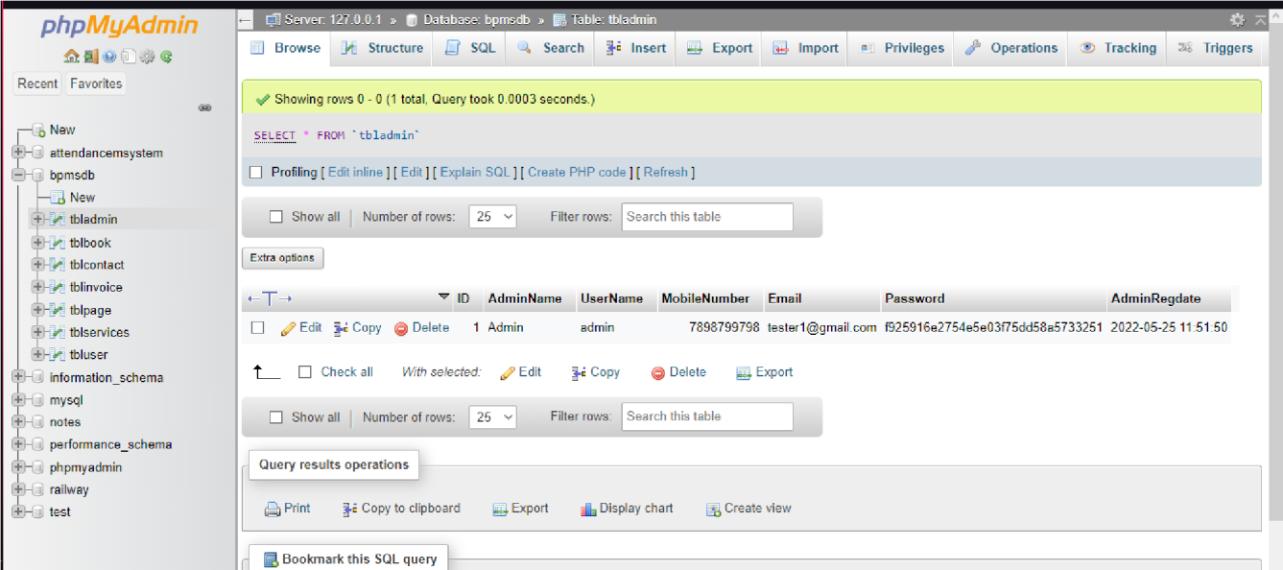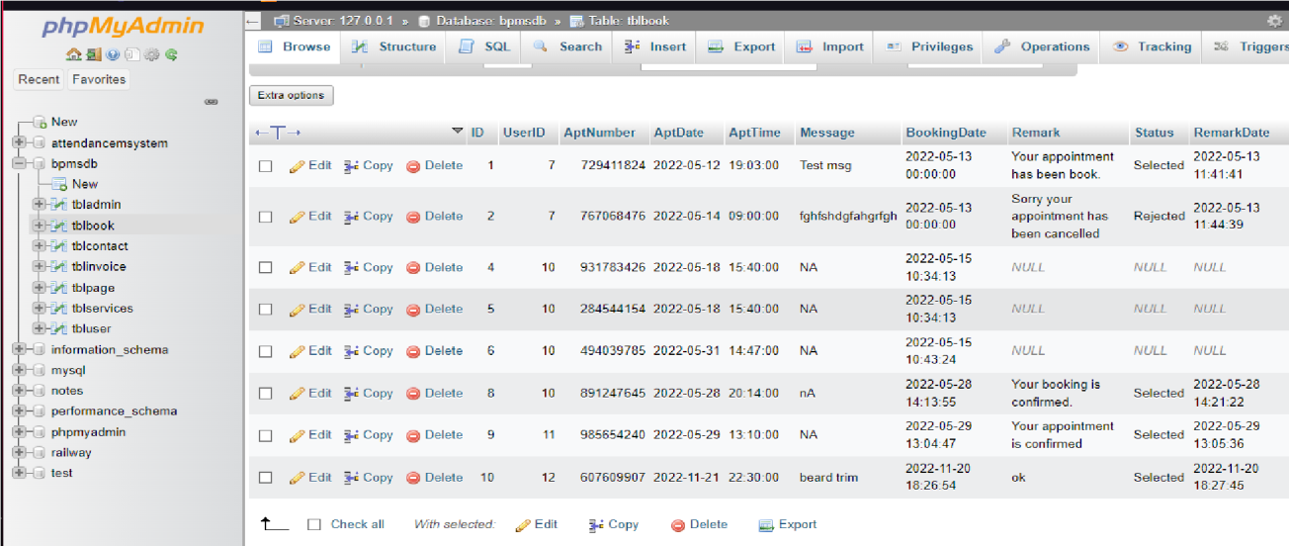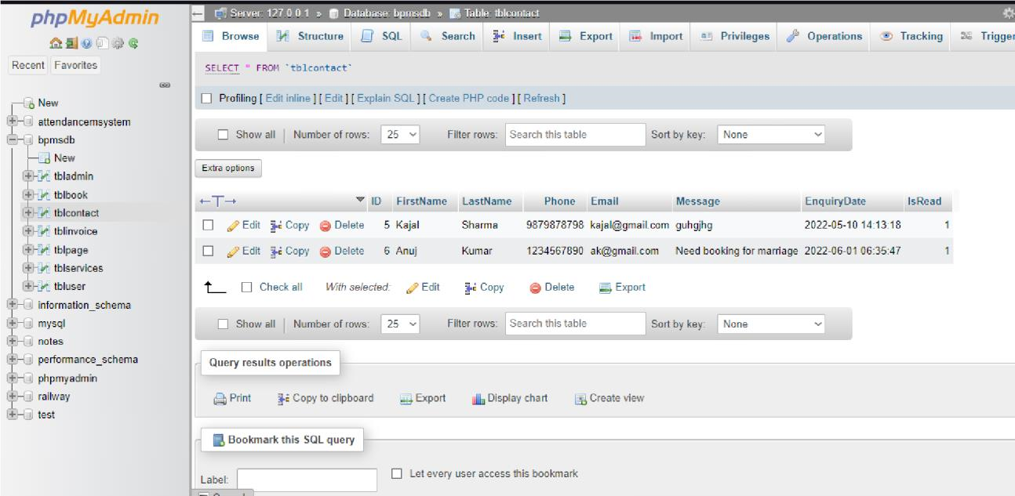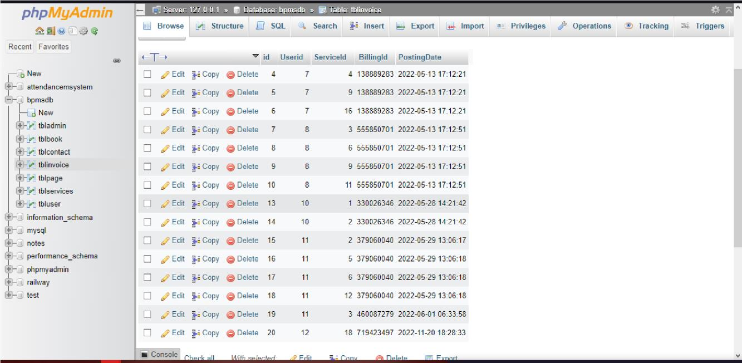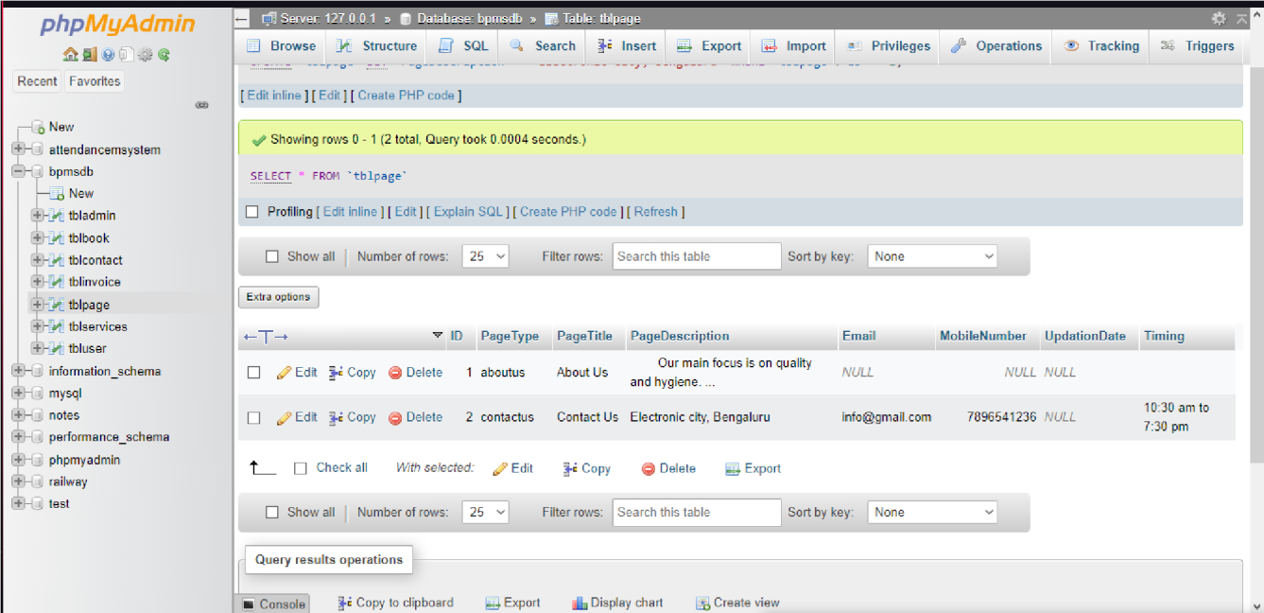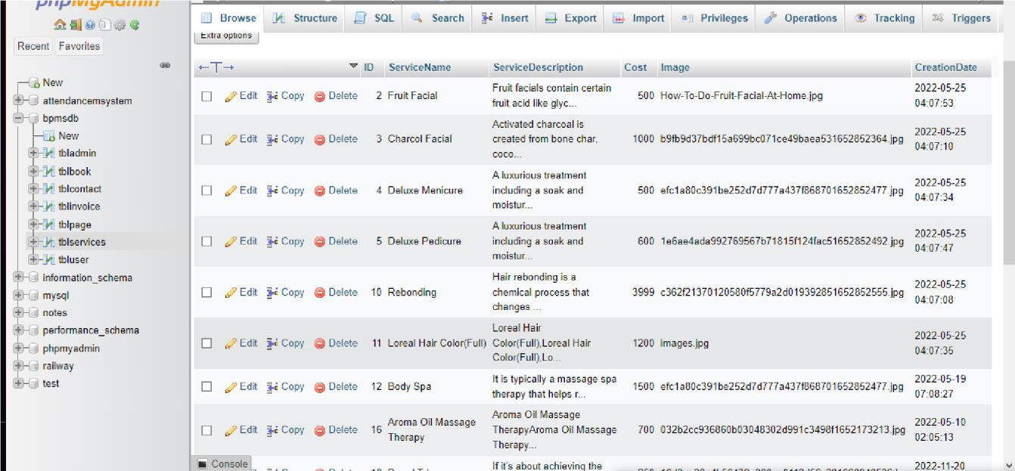

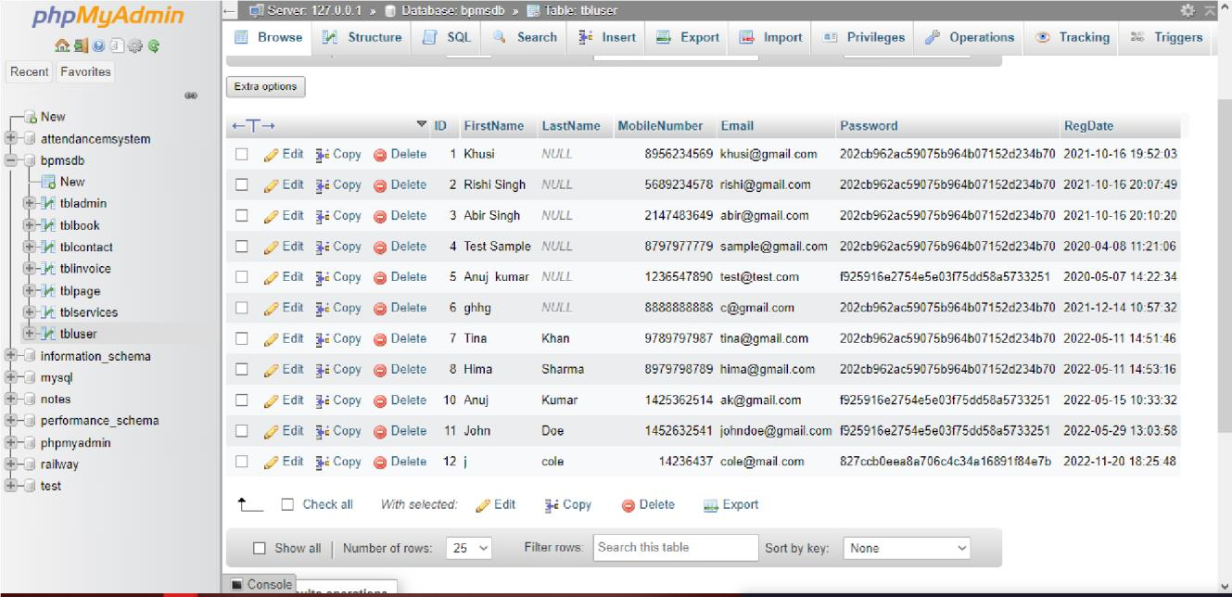

# Join Queries

Showcase at least 4 join queries

Write the query in English Language, Show the equivalent SQL statement and also a screenshot of the query and the results.

q1. search for invoice based on billing id or mobile number or firstname

and return first name, billing id, posting date

select distinct tbluser.FirstName,tblinvoice.BillingId,date(tblinvoice.PostingDate) as invoicedate from tbluser join tblinvoice on tbluser.ID=tblinvoice.Userid where tblinvoice.BillingId like '%$sdata%' || tbluser.MobileNumber like '%$sdata%' || tbluser.FirstName like '%$sdata%';

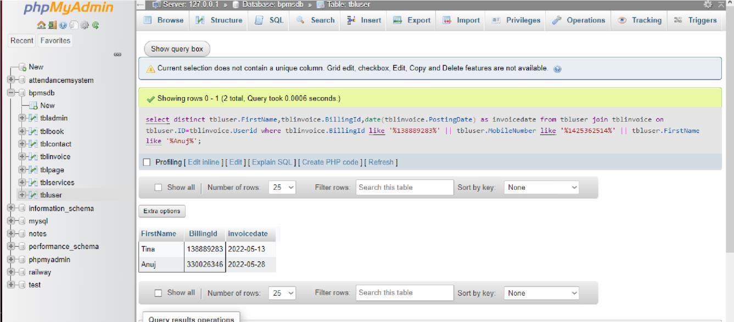

q2. search for appointment based on aptnumber or mobile number or firstname

and return first name, email, apt id, mobile number

[select](http://localhost/phpmyadmin/url.php?url=https://dev.mysql.com/doc/refman/8.0/en/select.html)

tbluser.FirstName,tbluser.LastName,tbluser.Email,tbluser.MobileNumber,tblb oo k.ID as

bid,tblbook.AptNumber,tblbook.AptDate,tblbook.AptTime,tblbook.Message,tblb oo k.BookingDate,tblbook.Status from tblbook join tbluser on tbluser.ID=tblbook.UserID where tblbook.AptNumber [like](http://localhost/phpmyadmin/url.php?url=https://dev.mysql.com/doc/refman/8.0/en/string-comparison-functions.html%23operator_like) '%729411824%' || tbluser.MobileNumber [like](http://localhost/phpmyadmin/url.php?url=https://dev.mysql.com/doc/refman/8.0/en/string-comparison-functions.html%23operator_like) '%$2147483649%' || tbluser.FirstName [like](http://localhost/phpmyadmin/url.php?url=https://dev.mysql.com/doc/refman/8.0/en/string-comparison-functions.html%23operator_like) '%$Abir

Singh%';

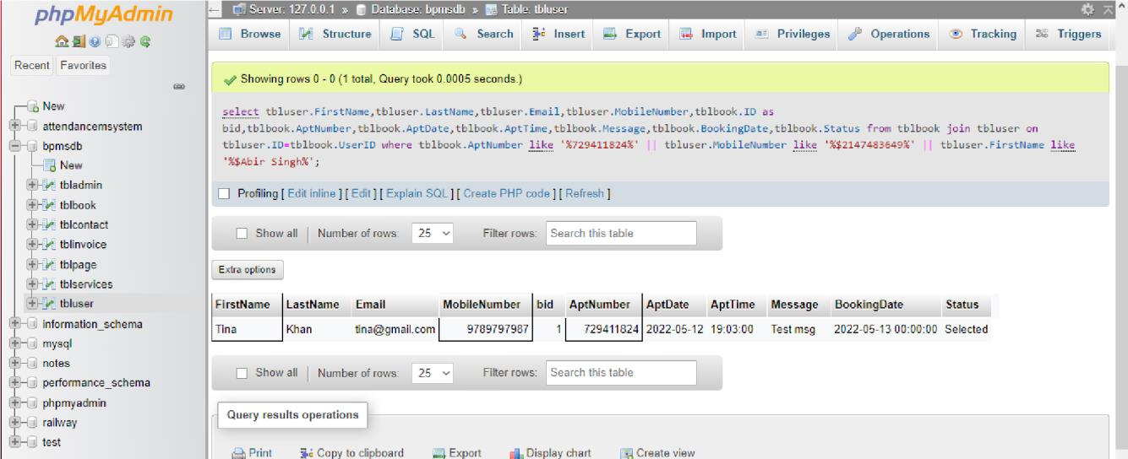

q3.get reports between dates and display

FirstName,LastName,BillingId,PostingDate

[select](http://localhost/phpmyadmin/url.php?url=https://dev.mysql.com/doc/refman/8.0/en/select.html) distinct

tbluser.FirstName,tbluser.LastName,tblinvoice.BillingId,tblinvoice.Posting

Da te from tbluser join tblinvoice on tbluser.ID=tblinvoice.Userid where date(tblinvoice.PostingDate) between '$2022-11-11' [and](http://localhost/phpmyadmin/url.php?url=https://dev.mysql.com/doc/refman/8.0/en/logical-operators.html%23operator_and) '$2022-12-12';

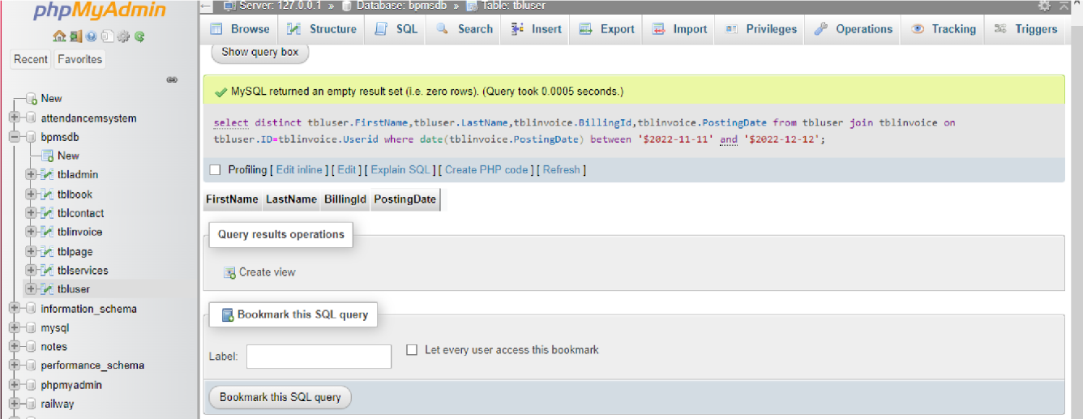

q4. retrieve first name, email, apt id, mobile number of rejected appointments [select](http://localhost/phpmyadmin/url.php?url=https://dev.mysql.com/doc/refman/8.0/en/select.html)

tbluser.FirstName,tbluser.LastName,tbluser.Email,tbluser.MobileNumber,tblb

oo k.ID as bid,tblbook.AptNumber,tblbook.AptDate,tblbook.AptTime,tblbook.Message,tblb oo k.BookingDate,tblbook.Status from tblbook join tbluser on tbluser.ID=tblbook.UserID where tblbook.Status='Rejected';

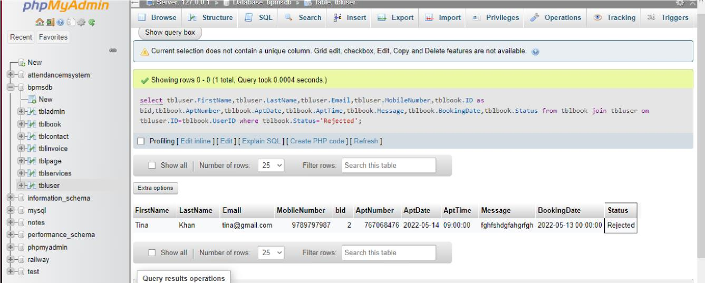

# Aggregate Functions

Showcase at least 4 Aggregate function queries

Write the query in English Language, Show the equivalent SQL statement and also a screenshot of the query and the results

q1. display sum of total price, from sales report over a span of 1 year or a month

[t](http://localhost/phpmyadmin/url.php?url=https://dev.mysql.com/doc/refman/8.0/en/select.html)

[selec](http://localhost/phpmyadmin/url.php?url=https://dev.mysql.com/doc/refman/8.0/en/select.html)

month

(

PostingDate

)

as

lmonth,

year

(

PostingDate

)

as

lyear,sum

(

Cost

)

as

totalprice

from

tblinvoice

join

tblservices

on

tblservices

.ID

=

tblinvoice

.ServiceId

where

date

(

tblinvoice

.PostingDate

)

between

'2022

-

05

-

05

'

[an](http://localhost/phpmyadmin/url.php?url=https://dev.mysql.com/doc/refman/8.0/en/logical-operators.html%23operator_and)

[d](http://localhost/phpmyadmin/url.php?url=https://dev.mysql.com/doc/refman/8.0/en/logical-operators.html%23operator_and)

'2022

-

11

-

05

'

group by

lmonth,lyear

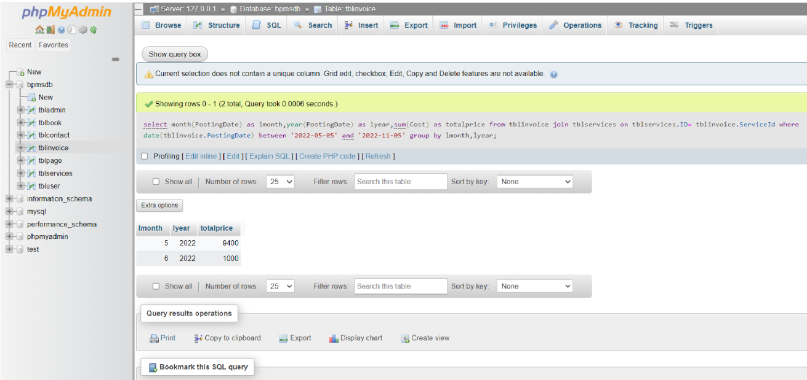

q2.display average of total price, from sales report over a span of 1 year or a month [select](http://localhost/phpmyadmin/url.php?url=https://dev.mysql.com/doc/refman/8.0/en/select.html) month(PostingDate) as lmonth,year(PostingDate) as lyear,avg(Cost) as totalprice from tblinvoice join tblservices on tblservices.ID=

tblinvoice.ServiceId where date(tblinvoice.PostingDate) between '2022-05- 05'

[and](http://localhost/phpmyadmin/url.php?url=https://dev.mysql.com/doc/refman/8.0/en/logical-operators.html%23operator_and) '2022-11-05' group by lmonth,lyear

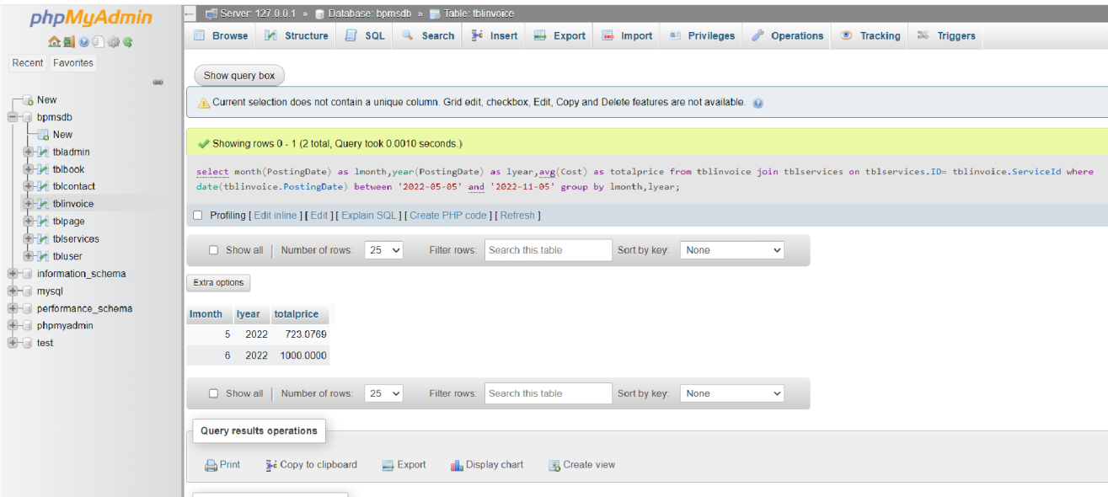

q3.display max cost, from sales report over a span of 1 year or a month

[select](http://localhost:70/phpmyadmin/url.php?url=https://dev.mysql.com/doc/refman/8.0/en/select.html) month(PostingDate) as lmonth,year(PostingDate) as lyear,[max(](http://localhost:70/phpmyadmin/url.php?url=https://dev.mysql.com/doc/refman/8.0/en/aggregate-functions.html%23function_max)Cost) as totalprice from tblinvoice join tblservices on tblservices.ID= tblinvoice.ServiceId where date(tblinvoice.PostingDate) between '2022-05-

05' [and](http://localhost:70/phpmyadmin/url.php?url=https://dev.mysql.com/doc/refman/8.0/en/logical-operators.html%23operator_and) '2022-11-05' group by lmonth,lyear;

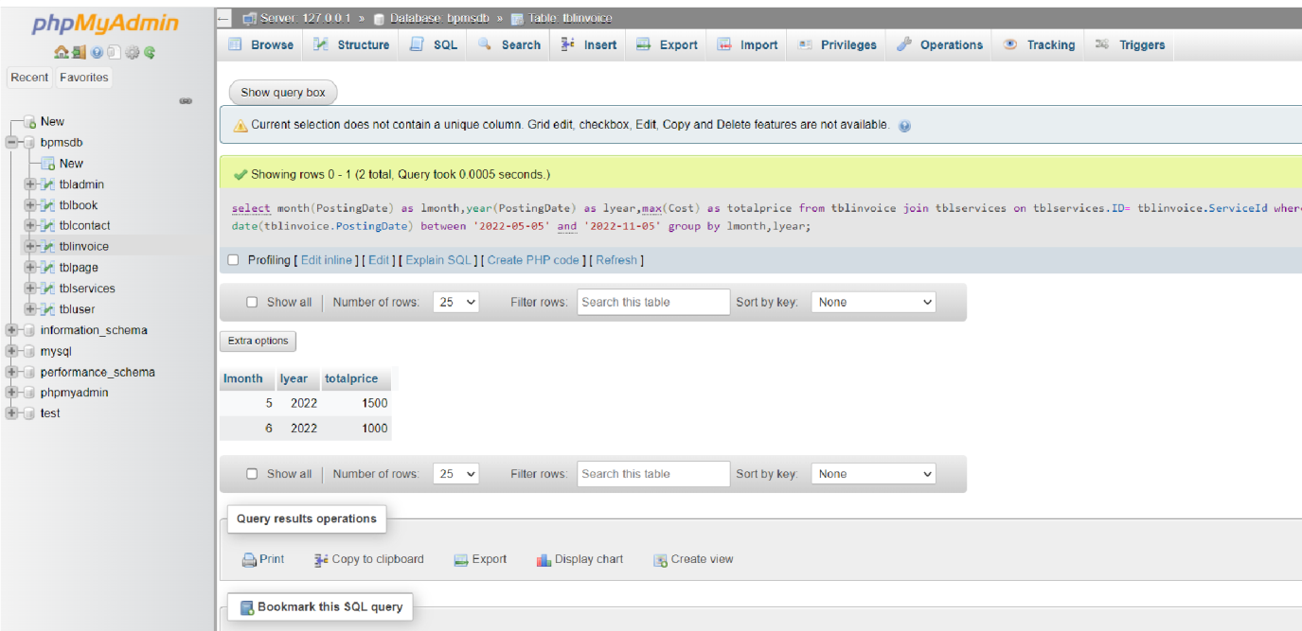

q3.display min cost, from sales report over a span of 1 year or a month

[select](http://localhost:70/phpmyadmin/url.php?url=https://dev.mysql.com/doc/refman/8.0/en/select.html) month(PostingDate) as lmonth,year(PostingDate) as lyear,[max(](http://localhost:70/phpmyadmin/url.php?url=https://dev.mysql.com/doc/refman/8.0/en/aggregate-functions.html%23function_max)Cost) as totalprice from tblinvoice join tblservices on tblservices.ID= tblinvoice.ServiceId where date(tblinvoice.PostingDate) between '2022-05-

05' [and](http://localhost:70/phpmyadmin/url.php?url=https://dev.mysql.com/doc/refman/8.0/en/logical-operators.html%23operator_and) '2022-11-05' group by lmonth,lyear;

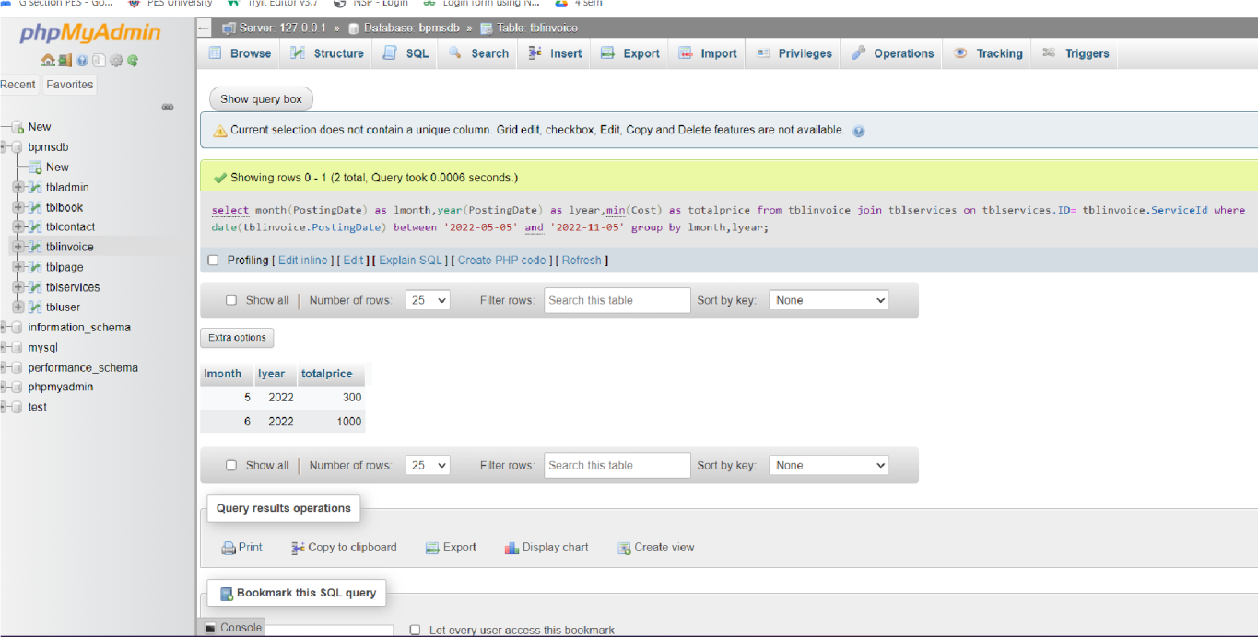

# Set Operations

Showcase at least 4 Set Operations queries

Write the query in English Language, Show the equivalent SQL statement and also a screenshot of the query and the results

1. display the users who have contacted the admin

[SELECT](http://localhost/phpmyadmin/url.php?url=https://dev.mysql.com/doc/refman/8.0/en/select.html) FirstName FROM tblcontact intersect [SELECT](http://localhost/phpmyadmin/url.php?url=https://dev.mysql.com/doc/refman/8.0/en/select.html) FirstName FROM tbluser;

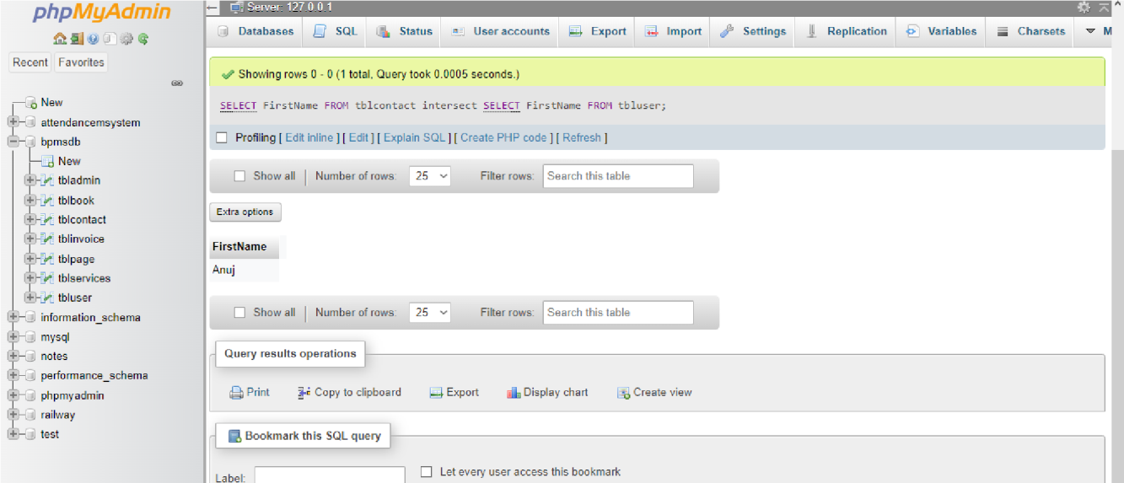

1. display remark in the union of user id and booking id

[SELECT](http://localhost:70/phpmyadmin/url.php?url=https://dev.mysql.com/doc/refman/8.0/en/select.html) b.Remark FROM `tblbook` b , `tbluser` u WHERE b.UserID= u.ID UNION

ALL [SELECT](http://localhost:70/phpmyadmin/url.php?url=https://dev.mysql.com/doc/refman/8.0/en/select.html) b.Remark FROM `tblbook` b , `tbluser` u;

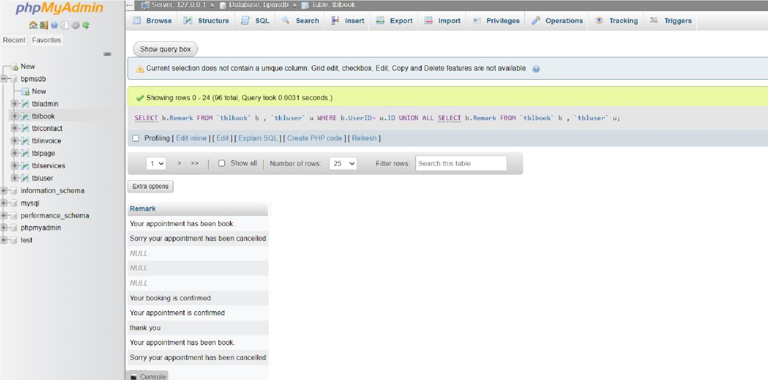

1. display not null remark in the union of user id and booking id

[SELECT](http://localhost:70/phpmyadmin/url.php?url=https://dev.mysql.com/doc/refman/8.0/en/select.html) b.Remark FROM `tblbook` b , `tbluser` u WHERE b.UserID= u.ID UNION

[SELECT](http://localhost:70/phpmyadmin/url.php?url=https://dev.mysql.com/doc/refman/8.0/en/select.html) b.Remark FROM `tblbook` b , `tbluser` u;

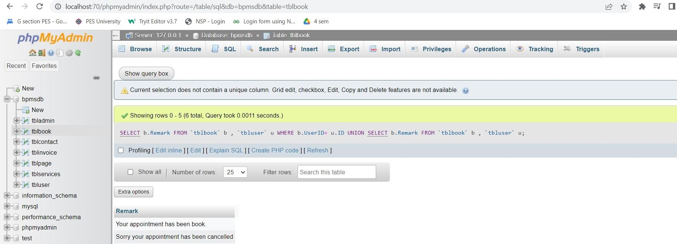

4 display remark in the intersection of user id and booking id

[SELECT](http://localhost:70/phpmyadmin/url.php?url=https://dev.mysql.com/doc/refman/8.0/en/select.html) b.Remark FROM `tblbook` b , `tbluser` u WHERE b.UserID= u.ID intersection [SELECT](http://localhost:70/phpmyadmin/url.php?url=https://dev.mysql.com/doc/refman/8.0/en/select.html) b.Remark FROM `tblbook` b , `tbluser` u;

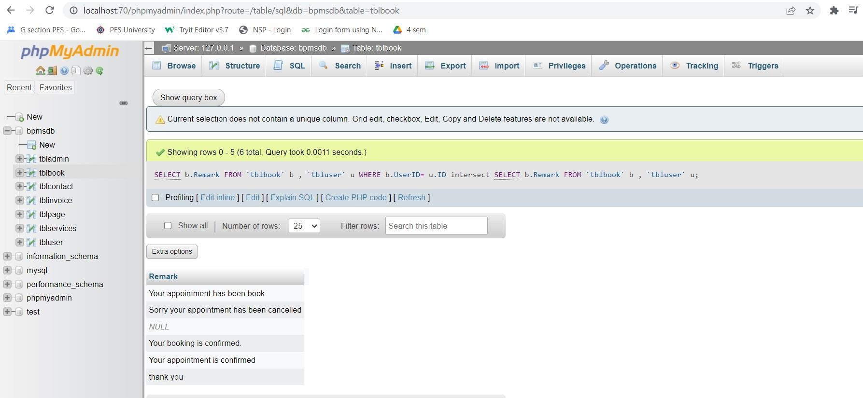

# Functions and Procedures

Create a Function and Procedure. State the objective of the function / Procedure. Run and display the results. q1. create a function to check if the cost of a service is high.

CREATE [or](http://localhost:70/phpmyadmin/url.php?url=https://dev.mysql.com/doc/refman/8.0/en/logical-operators.html%23operator_or) [replace](http://localhost:70/phpmyadmin/url.php?url=https://dev.mysql.com/doc/refman/8.0/en/replace.html) FUNCTION cost (ServiceName varchar(255)) RETURNS varchar(255) DETERMINISTIC BEGIN [DECLARE](http://localhost:70/phpmyadmin/url.php?url=https://dev.mysql.com/doc/refman/8.0/en/declare.html%23declare) cost INT; [DECLARE](http://localhost:70/phpmyadmin/url.php?url=https://dev.mysql.com/doc/refman/8.0/en/declare.html%23declare) ans

VARCHAR(255); [SET](http://localhost:70/phpmyadmin/url.php?url=https://dev.mysql.com/doc/refman/8.0/en/set.html) cost = [(SELECT](http://localhost:70/phpmyadmin/url.php?url=https://dev.mysql.com/doc/refman/8.0/en/select.html) cost from tblinvoice where (ServiceName= tblinvoice.ServiceName)); [IF](http://localhost:70/phpmyadmin/url.php?url=https://dev.mysql.com/doc/refman/8.0/en/control-flow-functions.html%23function_if) cost > 400 THEN [SET](http://localhost:70/phpmyadmin/url.php?url=https://dev.mysql.com/doc/refman/8.0/en/set.html) ans = "high cost"; ELSE

[SET a](http://localhost:70/phpmyadmin/url.php?url=https://dev.mysql.com/doc/refman/8.0/en/set.html)ns = "low cost"; END [IF;](http://localhost:70/phpmyadmin/url.php?url=https://dev.mysql.com/doc/refman/8.0/en/control-flow-functions.html%23function_if) RETURN ans; END;

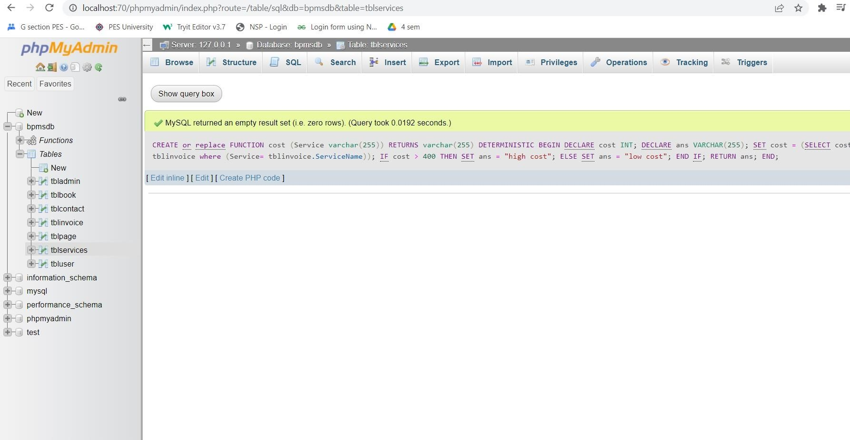

q2. retrieve number of days since service creation

CREATE [or](http://localhost:70/phpmyadmin/url.php?url=https://dev.mysql.com/doc/refman/8.0/en/logical-operators.html%23operator_or) [REPLACE](http://localhost:70/phpmyadmin/url.php?url=https://dev.mysql.com/doc/refman/8.0/en/replace.html) PROCEDURE `getnumbersofdayssince`[(IN](http://localhost:70/phpmyadmin/url.php?url=https://dev.mysql.com/doc/refman/8.0/en/comparison-operators.html%23function_in) `serviceid`

VARCHAR(25), [IN](http://localhost:70/phpmyadmin/url.php?url=https://dev.mysql.com/doc/refman/8.0/en/comparison-operators.html%23function_in) `cdate` DATE, OUT `ANS` INT) BEGIN [SET](http://localhost:70/phpmyadmin/url.php?url=https://dev.mysql.com/doc/refman/8.0/en/set.html) ANS = TIMESTAMPDIFF(YEAR, DOB, CURDATE()); [UPDATE](http://localhost:70/phpmyadmin/url.php?url=https://dev.mysql.com/doc/refman/8.0/en/update.html) tblservices [SET](http://localhost:70/phpmyadmin/url.php?url=https://dev.mysql.com/doc/refman/8.0/en/set.html) tblservices.ServiceDescription =TIMESTAMPDIFF(YEAR, dob, CURDATE()) WHERE tblservices.ID=serviceid; END;

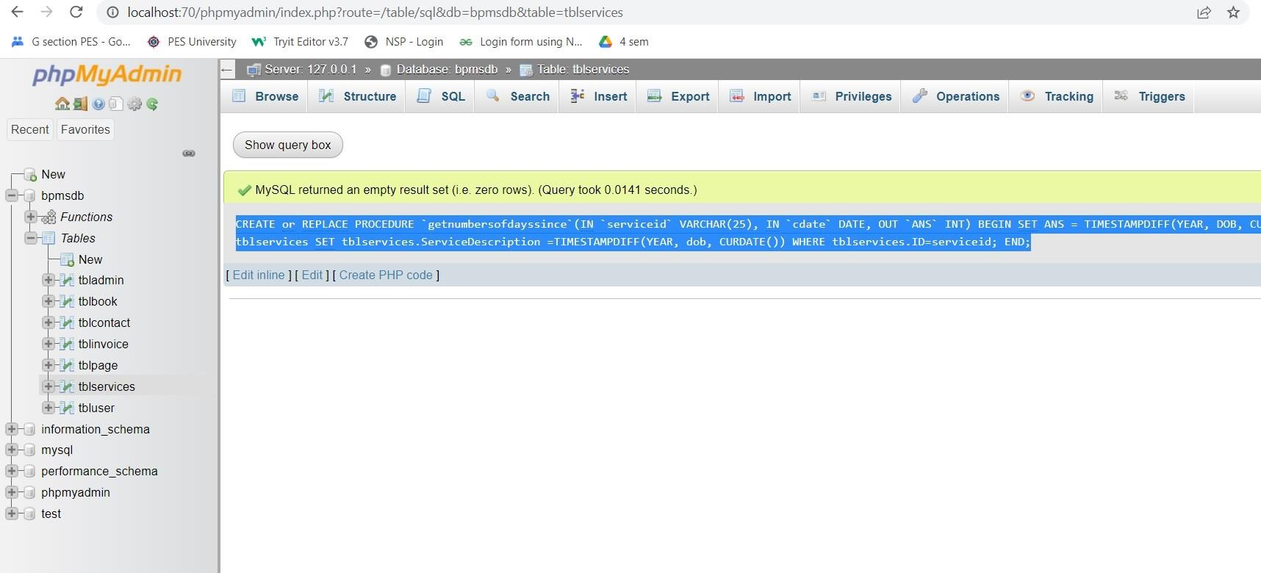

# Triggers and Cursors

Create a Trigger and a Cursor. State the objective. Run and display the results. q1.trigger when is read is greater than 1

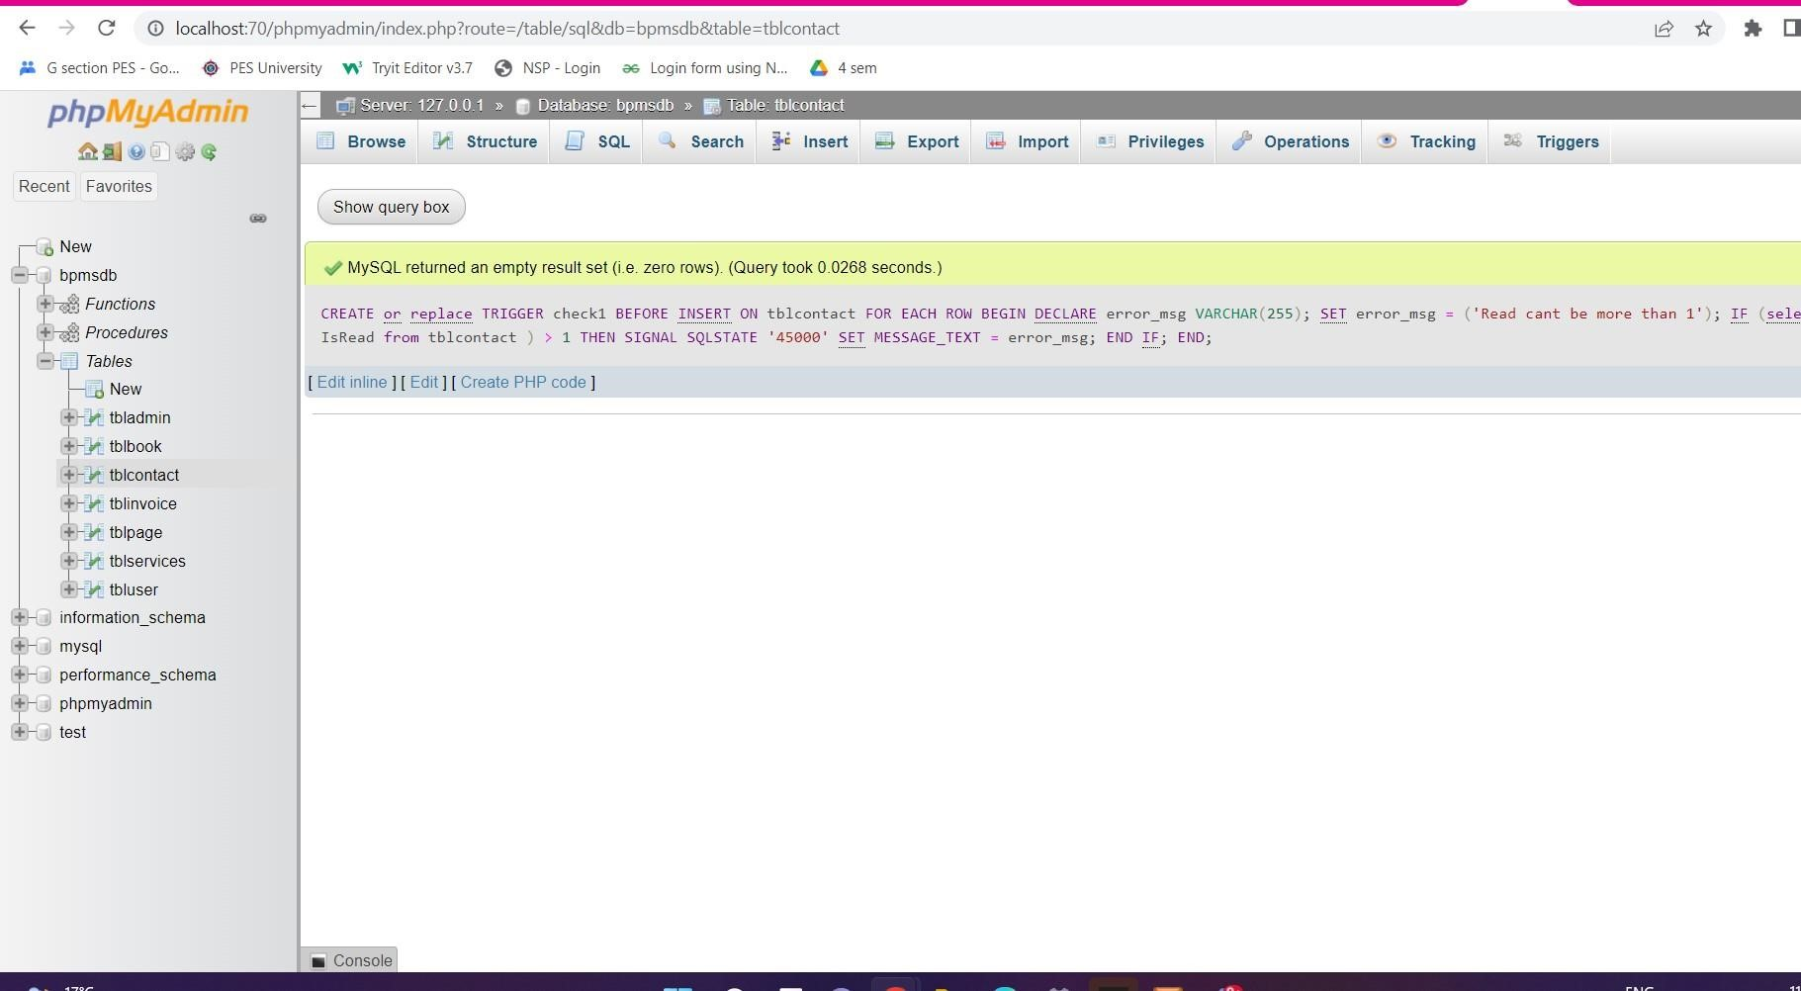

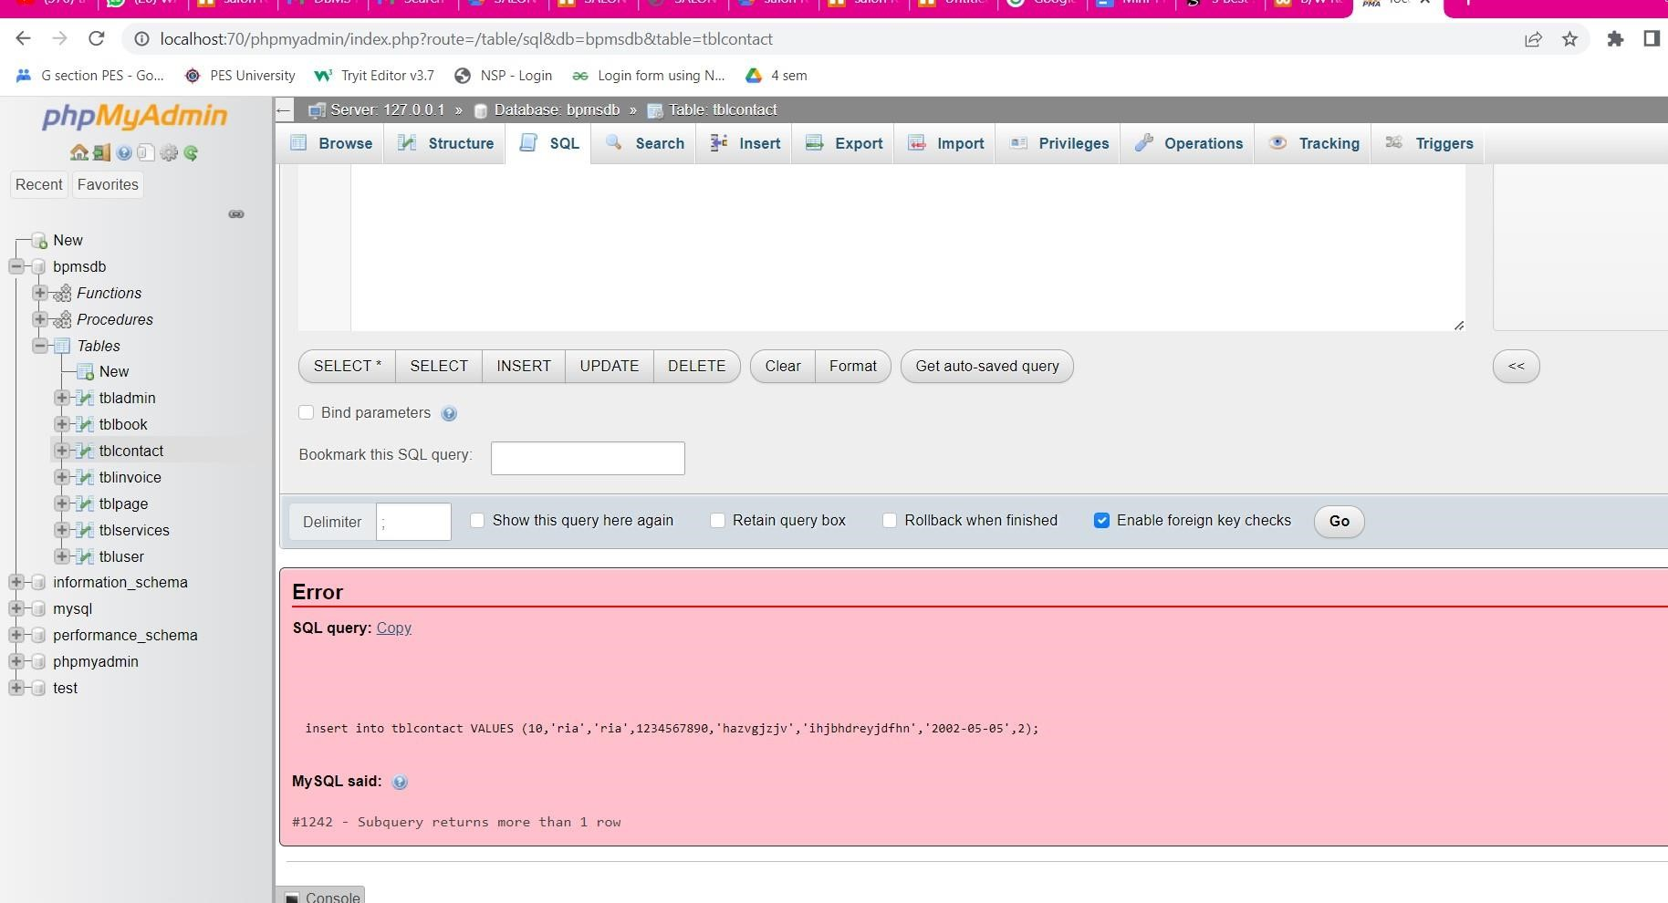 q2.cursor to get user id

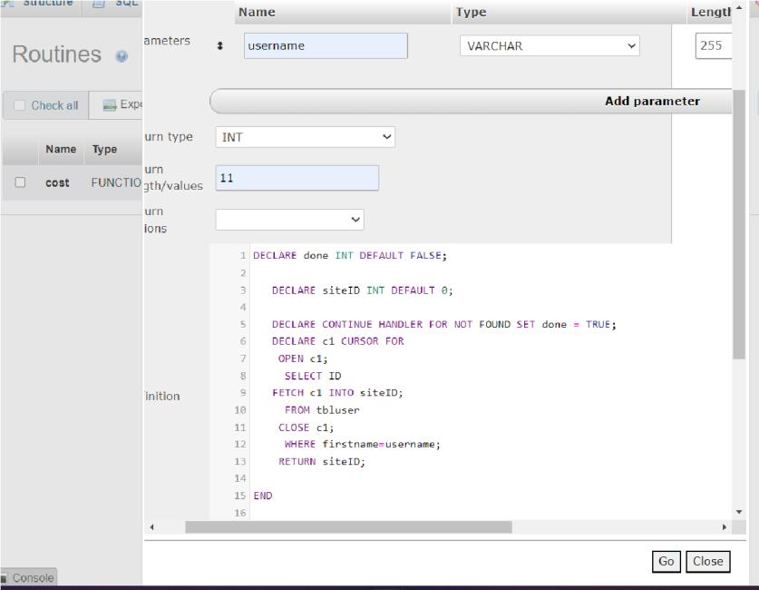

# Developing a Frontend

The frontend should support

1. Addition, Modification and Deletion of records from any chosen table
2. There should be a window to accept and run any SQL statement and display the result

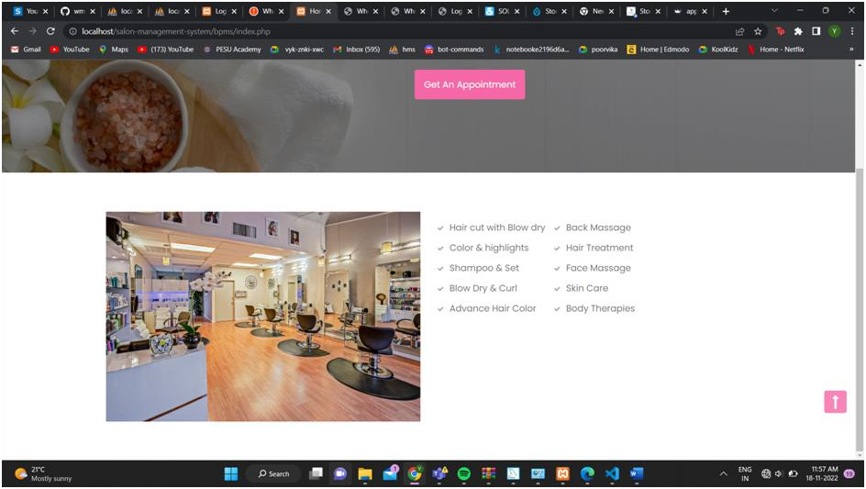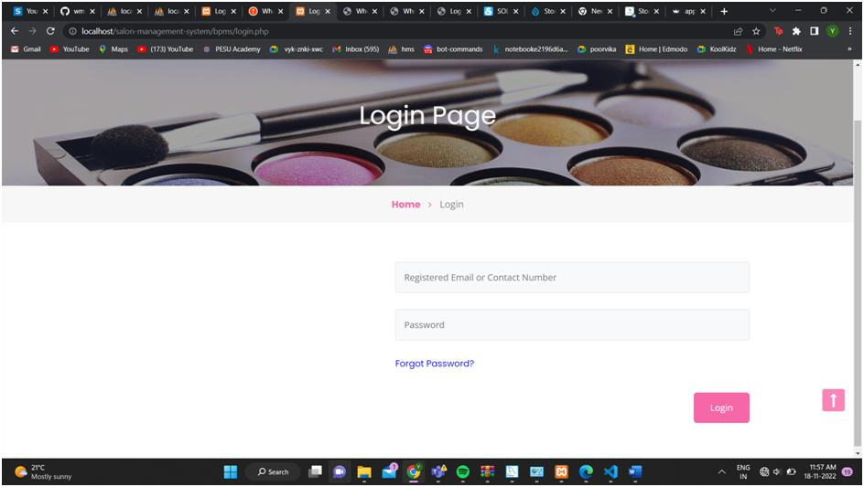

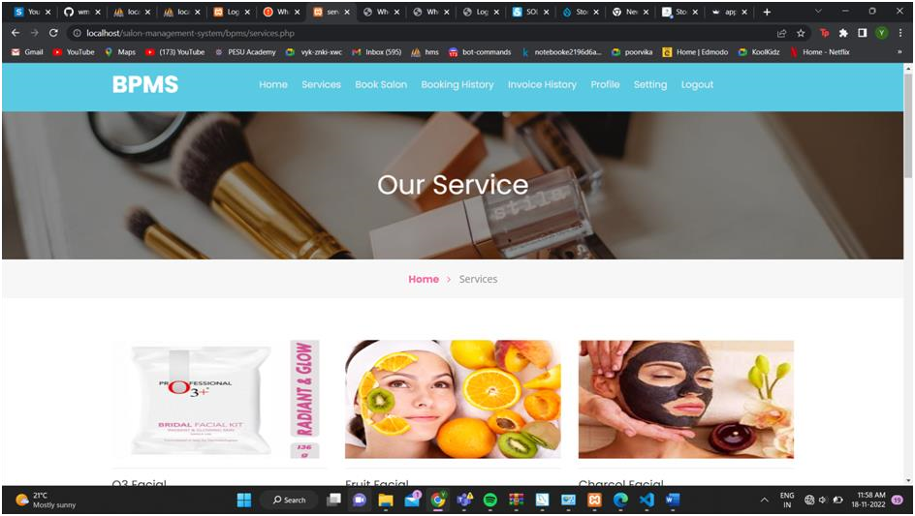

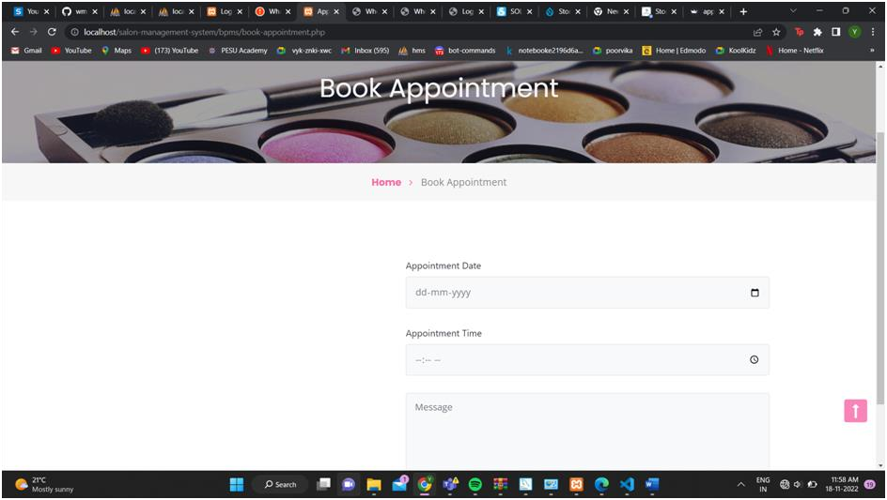

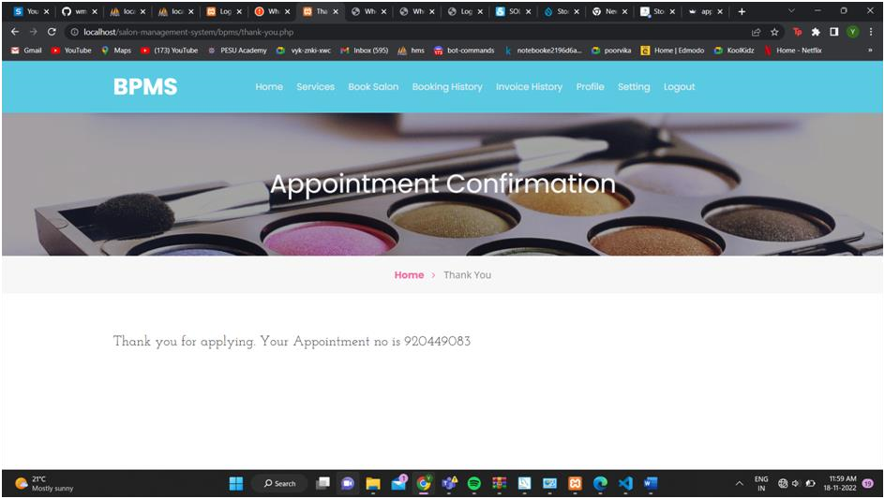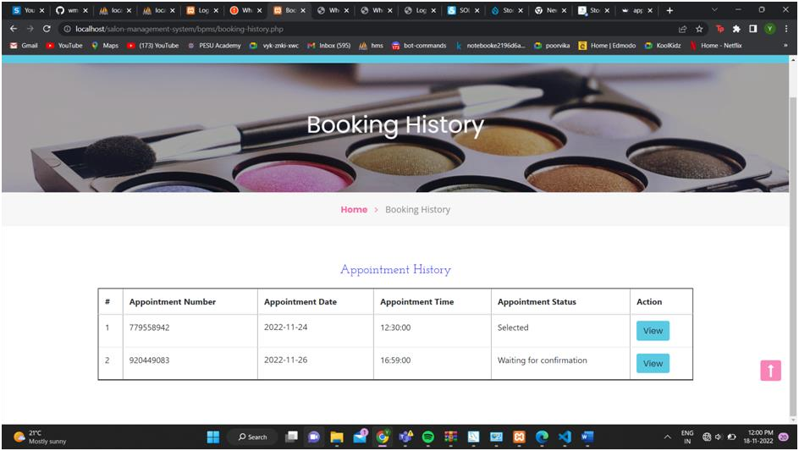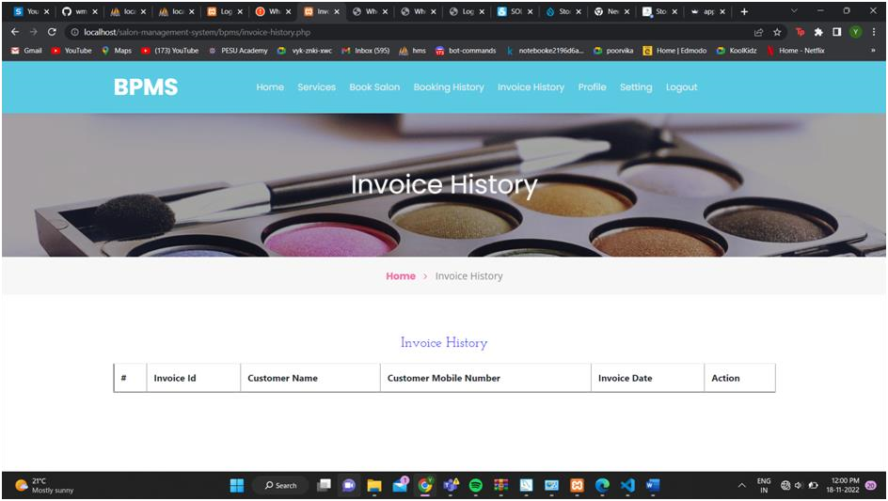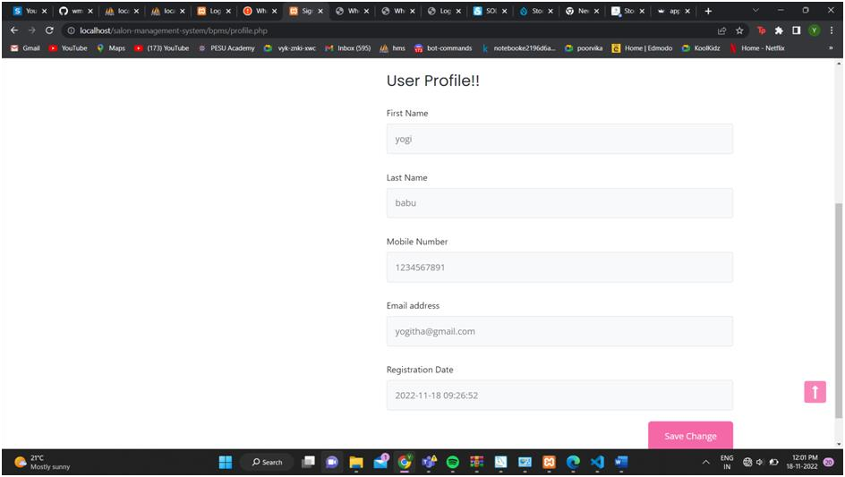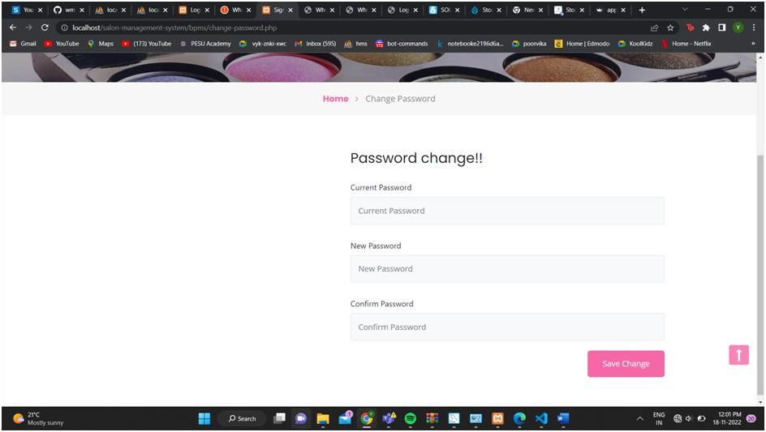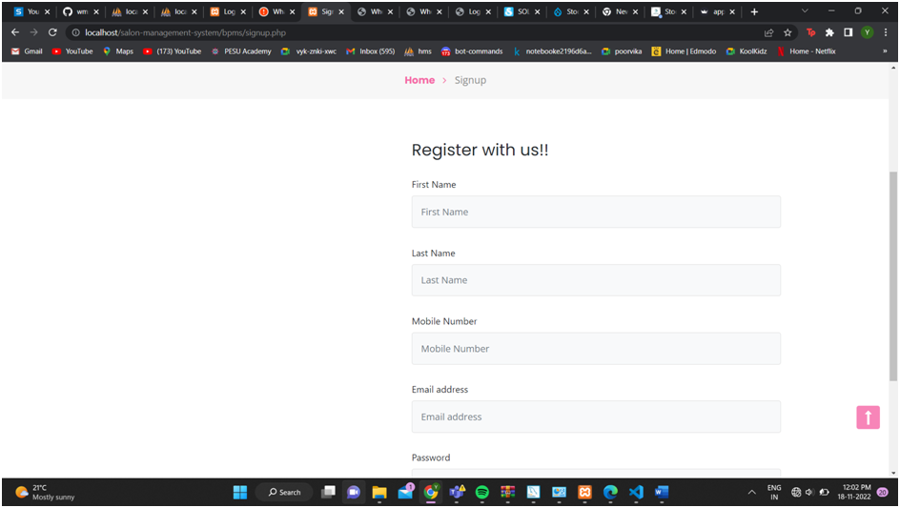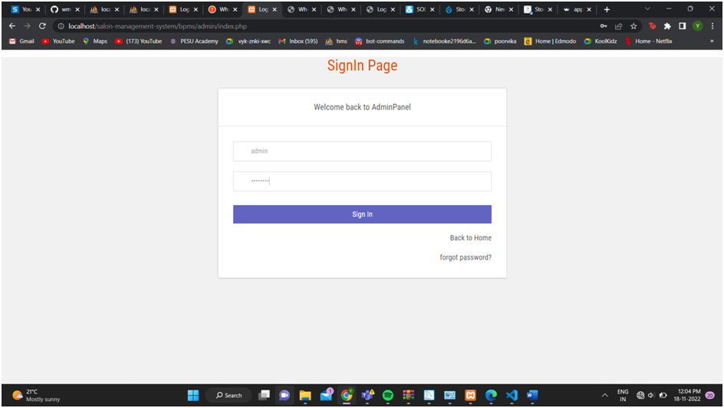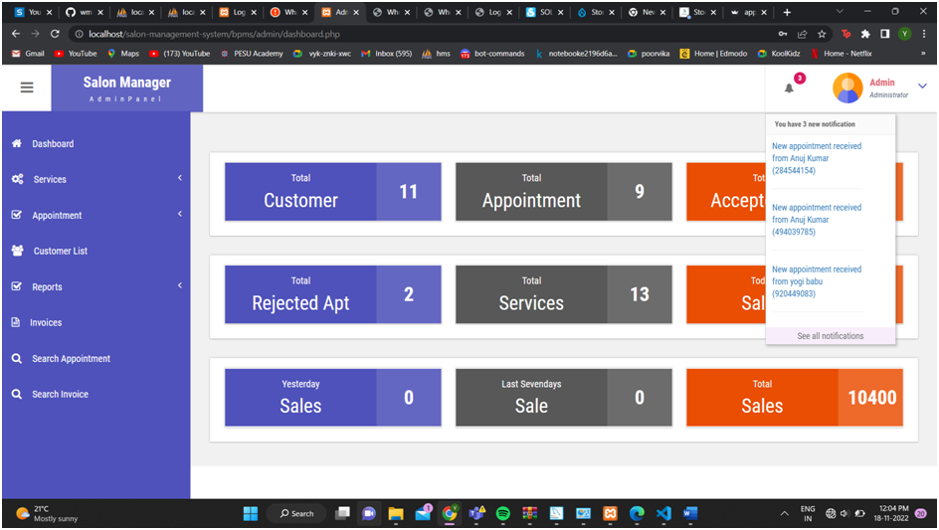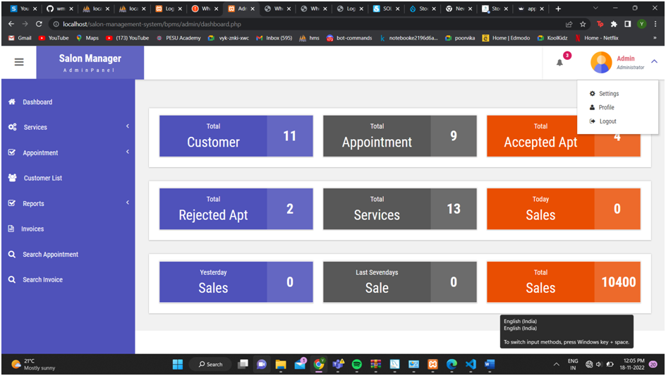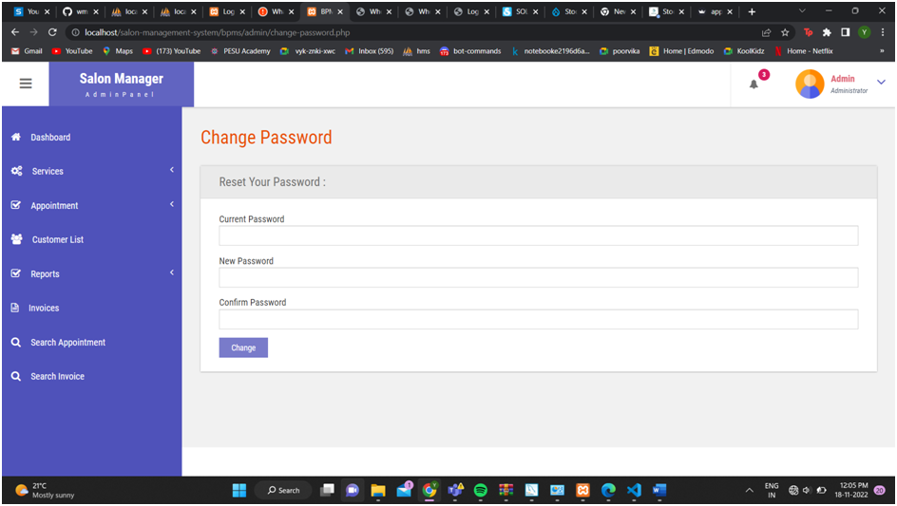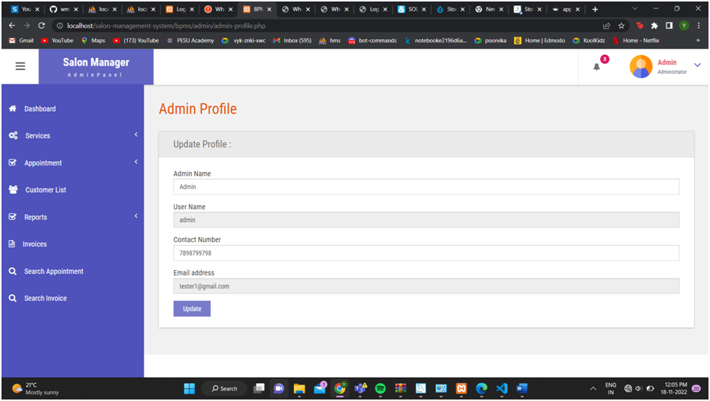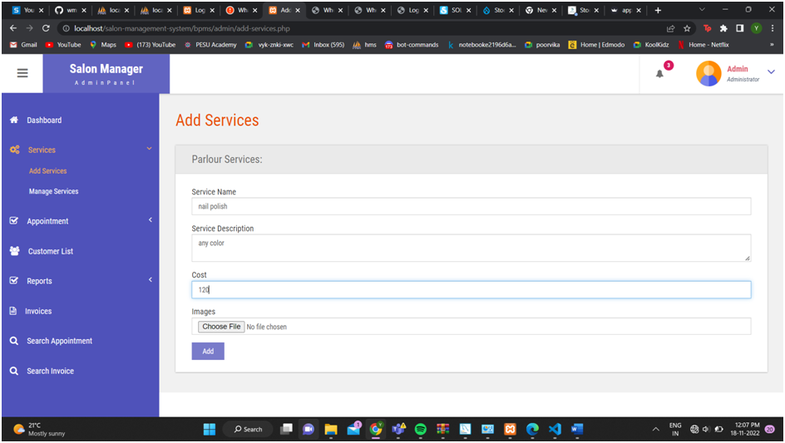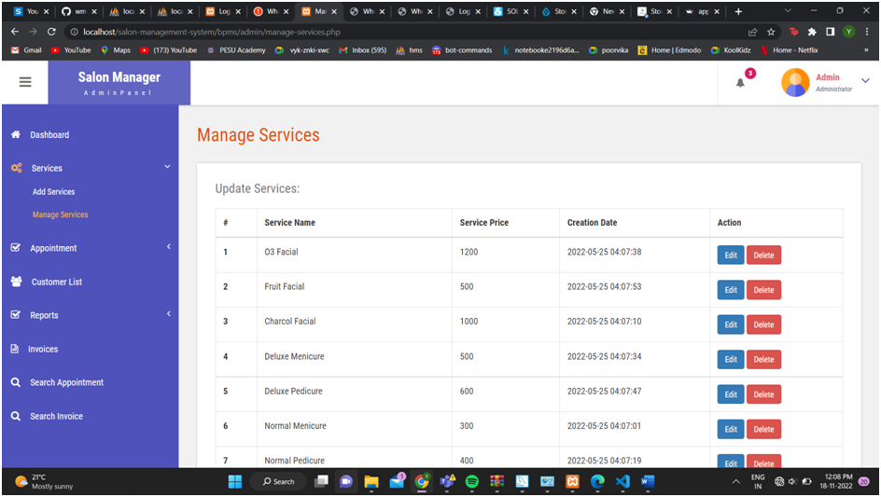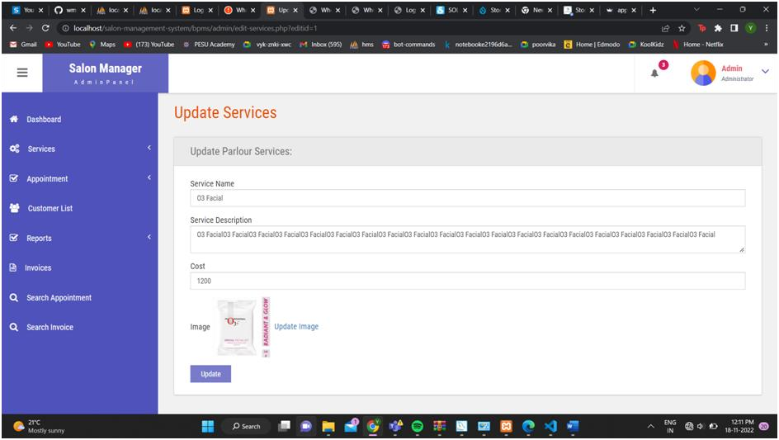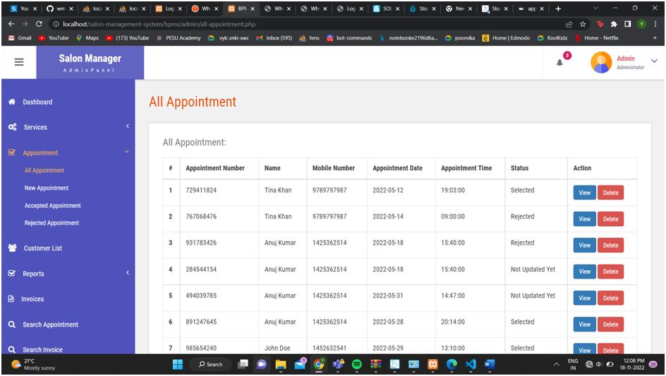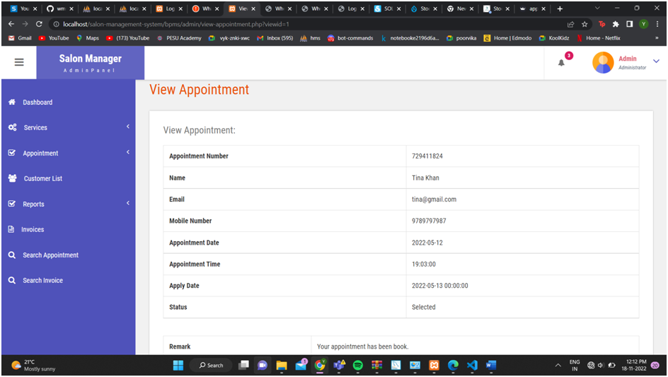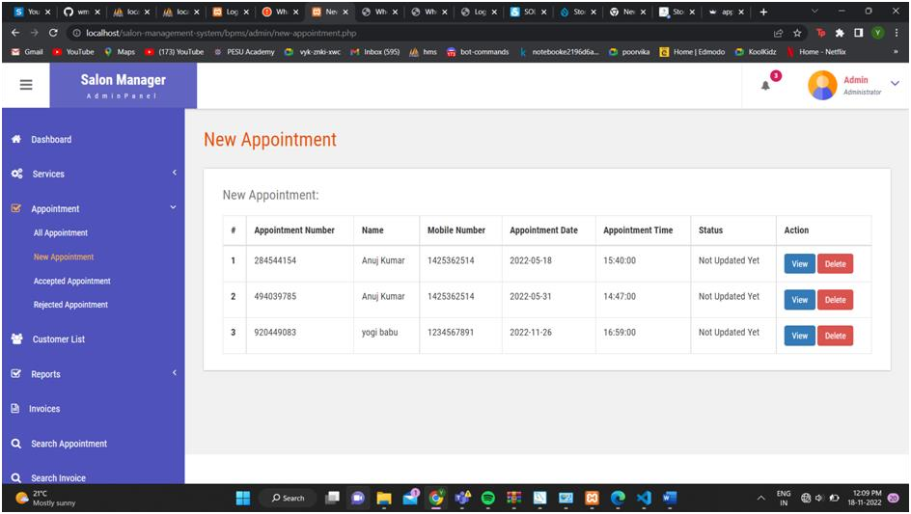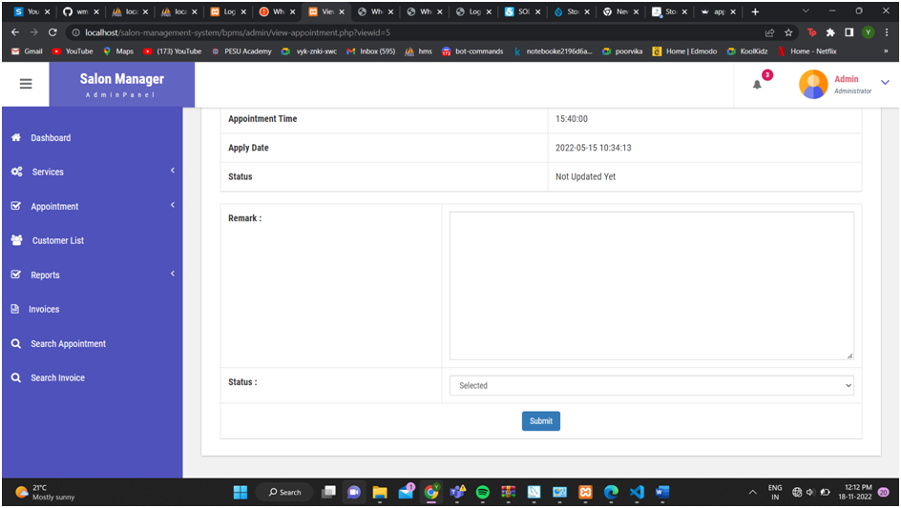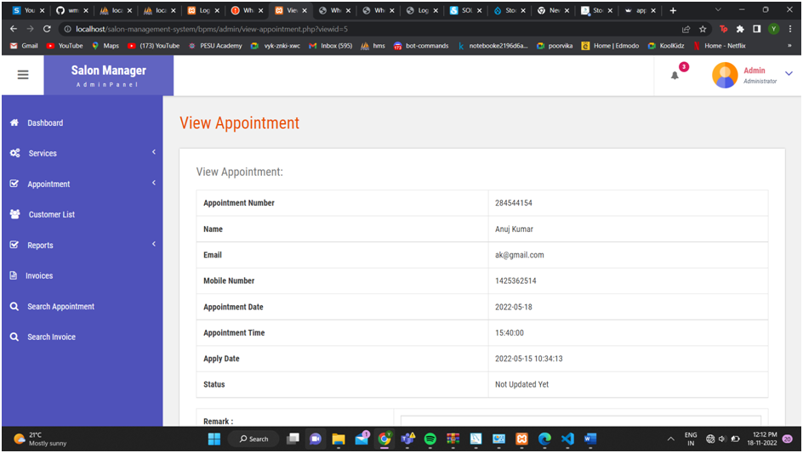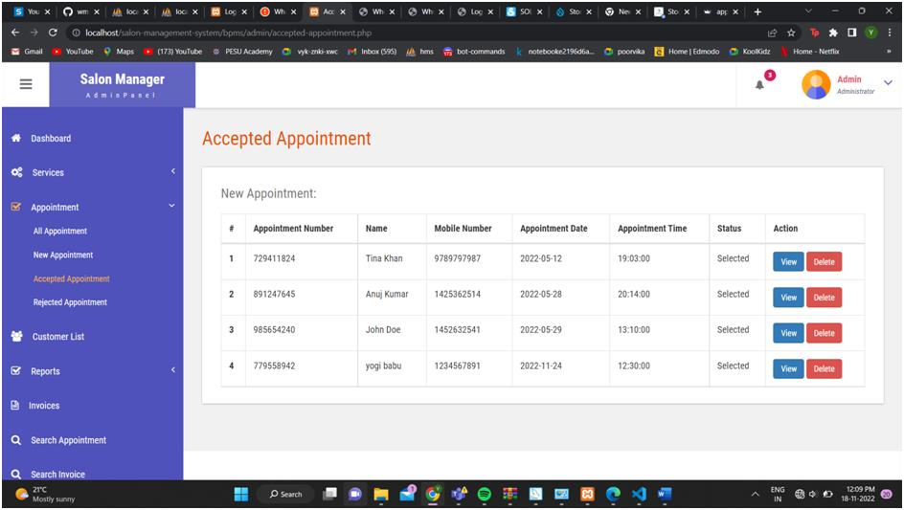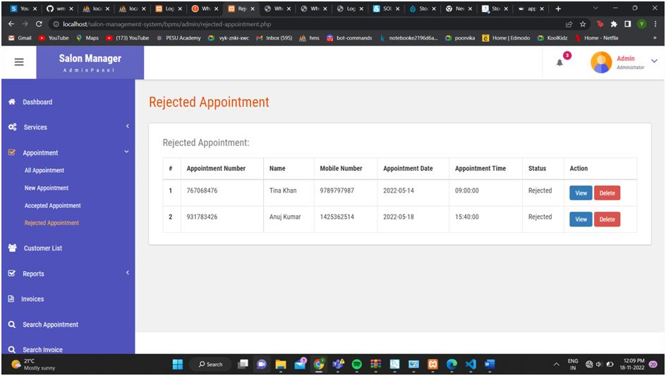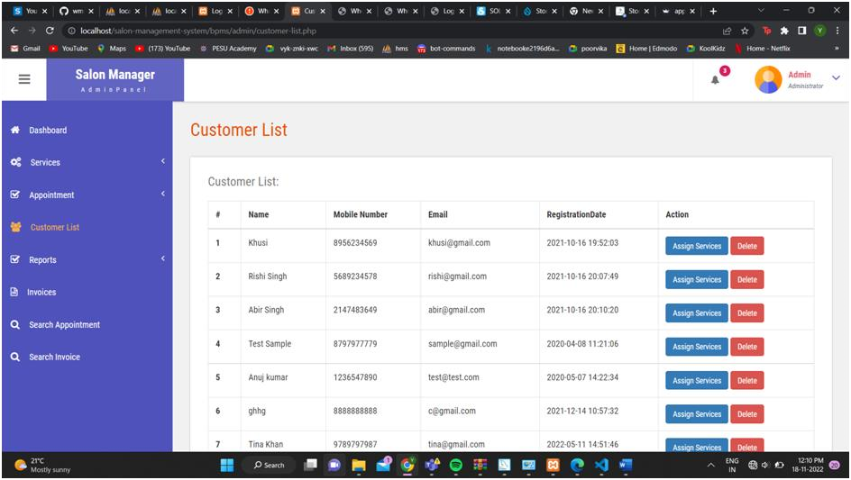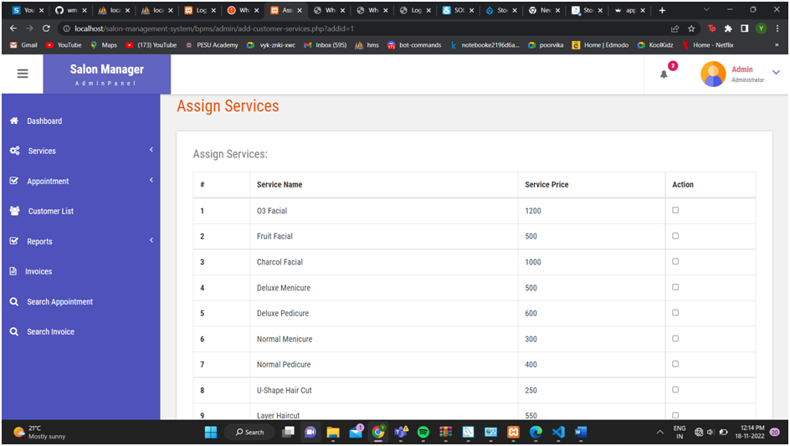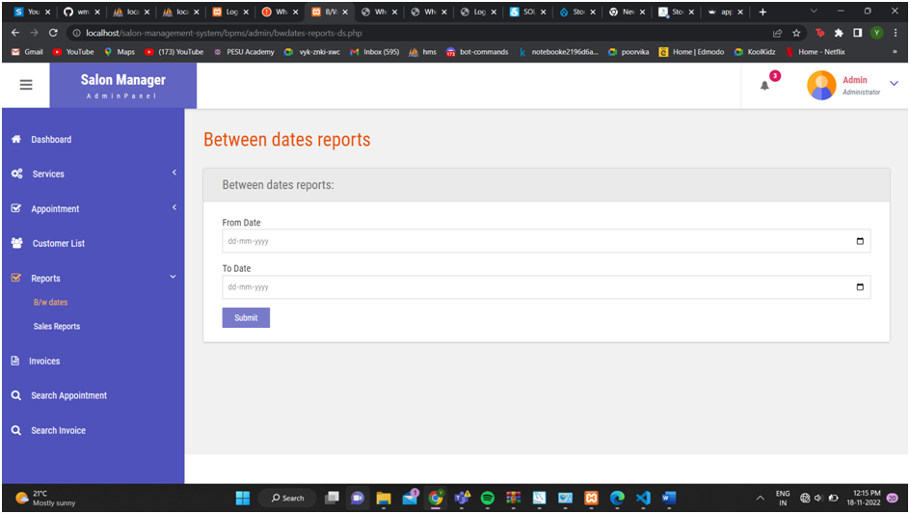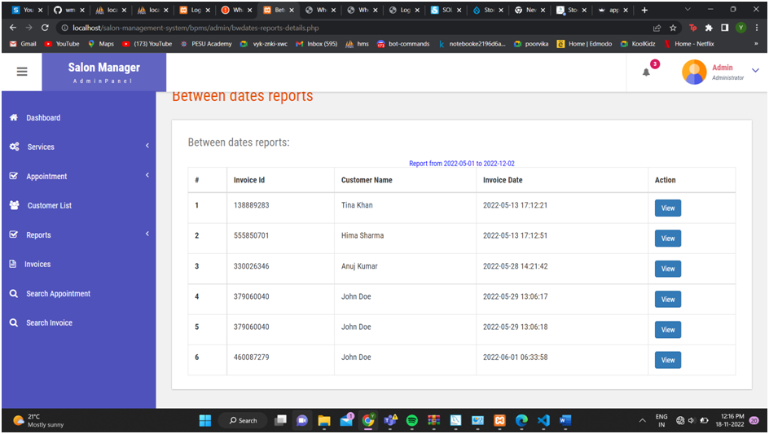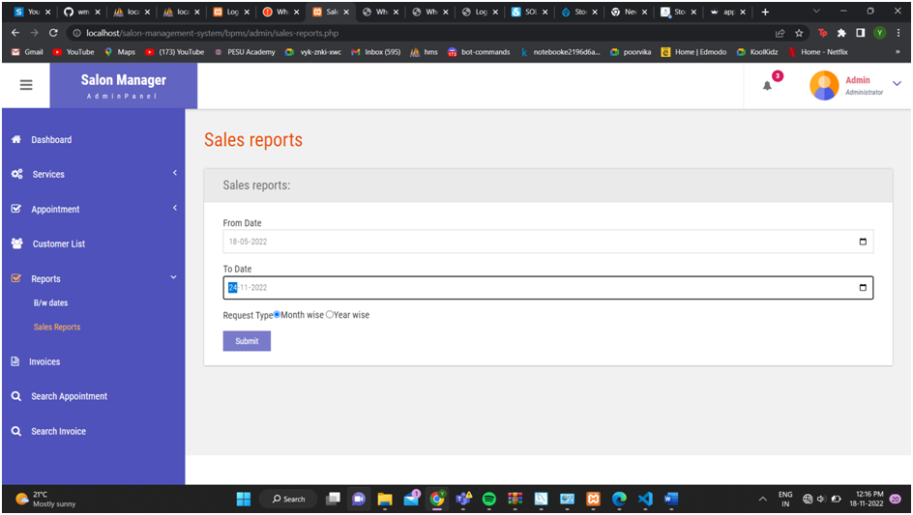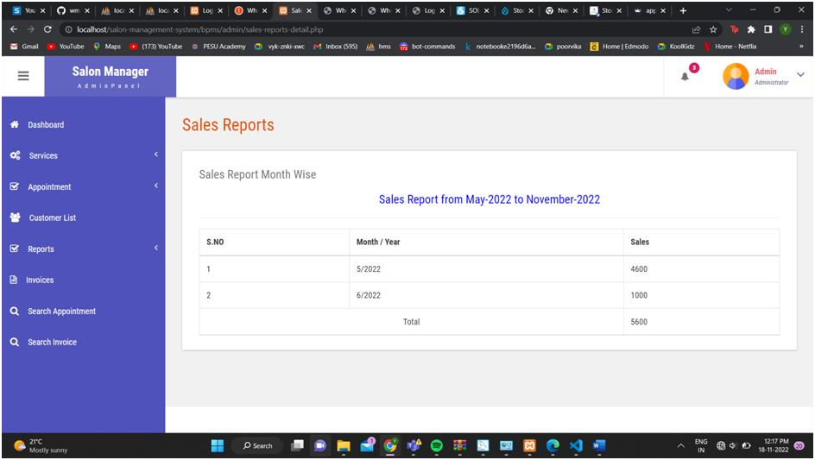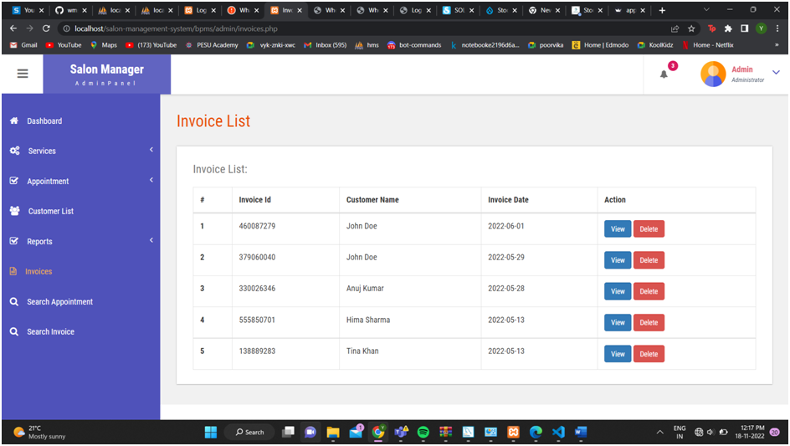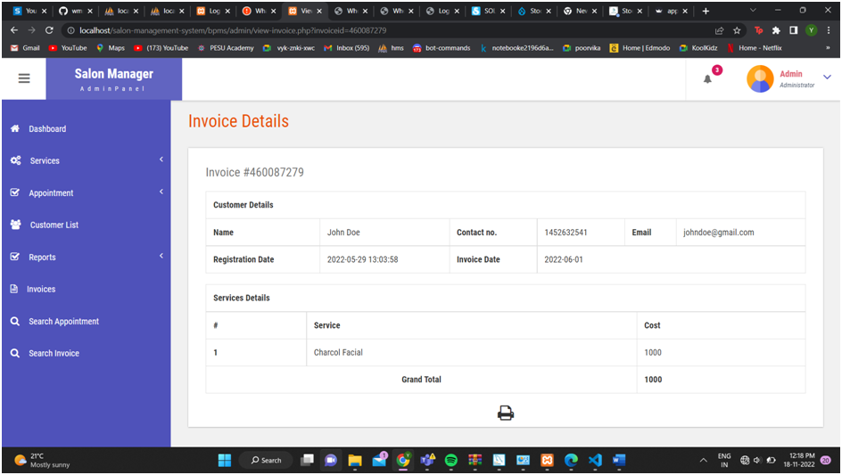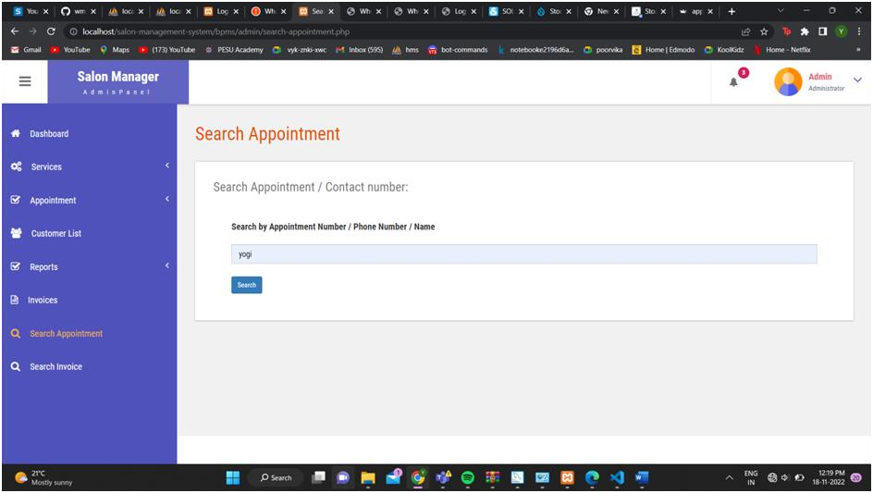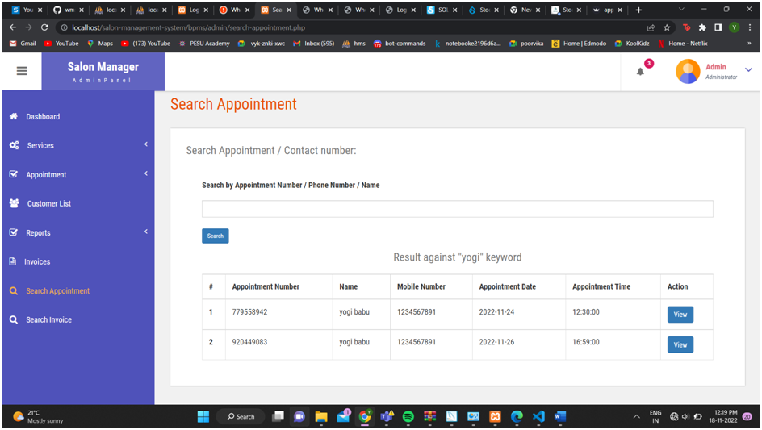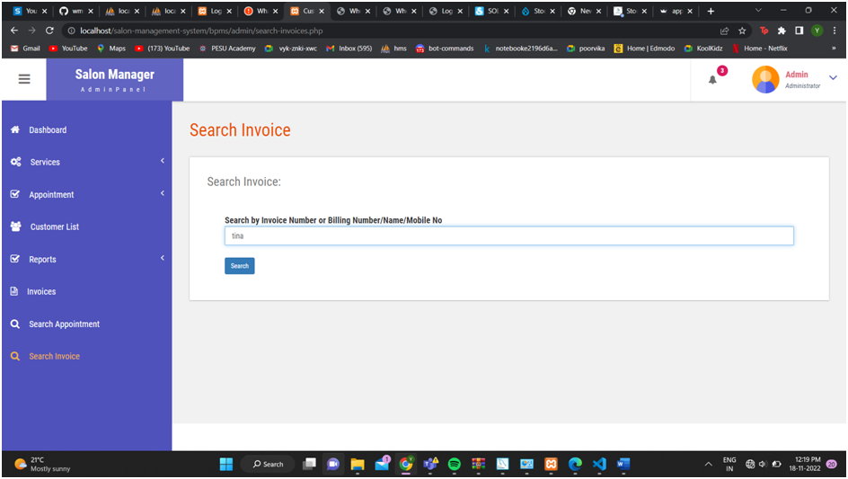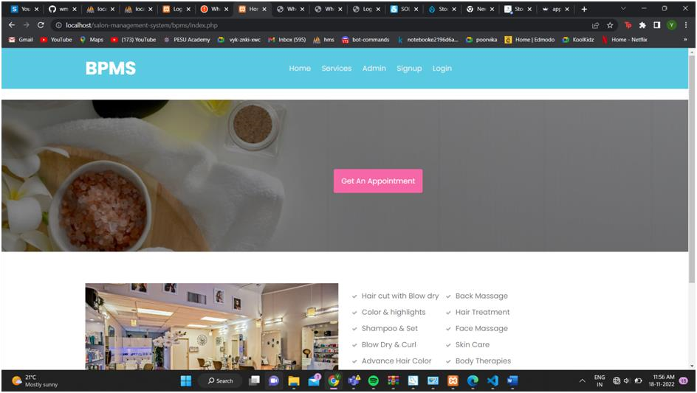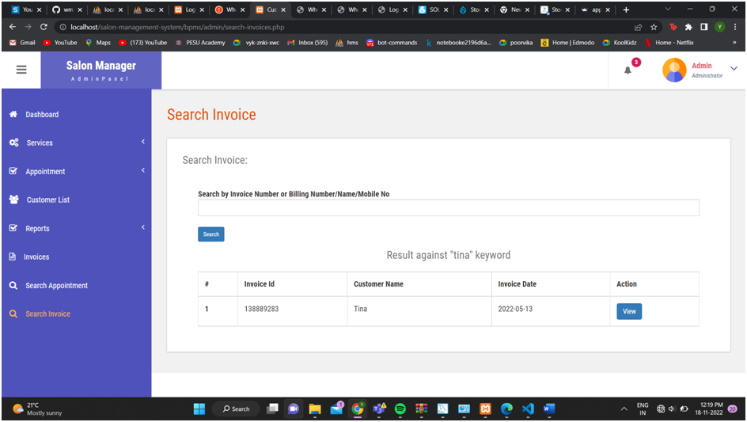

**Conclusion**

This system will help saloons to pitch their business underneath their space to expand their everyday business.

This project also helps local vendors to show their presence globally on the internet and serve their customers with their art.

In the salon and beauty industry, the Online Reservation System is suitable for use to reduce

customer waiting time and experience a hassle-free environment

**References (If any)**

* salonist.io
* <https://www.salonmanagementapp.com/>
* https://thesalonbusiness.com/best-salon-softwar